Data-Driven Analysis and Machine-Learning Prediction of Chemical Short-Range Order in Metallic Alloys

Thesis submitted in partial fulfillment
For the Award of
B.Tech DEGREE
in
METALLURGICAL ENGINEERING
by
Abhinav Choudhary (23145102)
Yuvraj Singh (23145101)
Ashish Gautam (23145017)
Under the guidance of
Prof. Vikas Jindal
(Supervisor)
DEPARTMENT OF METALLURGICAL ENGINEERING
INDIAN INSTITUTE OF TECHNOLOGY
(BANARAS HINDU UNIVERSITY)
VARANASI - 221005
November 2026
DECLARATION BY THE CANDIDATE(S)
It is certified that the work contained in the thesis entitled “Data-Driven Analysis and Machine-Learning Prediction of Chemical Short-Range Order in Metallic Alloys” by Abhinav Choudhary (23145102), Yuvraj Singh (23145101) and Ashish Gautam (23145017), in partial fulfillment of the requirements for the award of the B.Tech degree in the Department of Metallurgical Engineering at Indian Institute of Technology (BHU) Varanasi, is a record of the candidates’ own work carried out under the supervision of Prof. Vikas Jindal, and that this work has not been submitted elsewhere for a degree. We declare that we have faithfully acknowledged and given due credit to the research work of others wherever it has been used in this thesis. We further declare that we have not wilfully copied any other’s work, paragraphs, text, data, results, etc., reported in journals, books, magazines, reports, dissertations, theses, etc., or available at websites, and have not included them in this thesis or cited them as our own work.
Date:
Place: IIT (BHU), Varanasi
______________________ | ______________________ | ______________________
Abhinav Choudhary  Roll No. 23145102 | Yuvraj Singh  Roll No. 23145101 | Ashish Gautam  Roll No. 23145017

______________________
Supervisor
Prof. Vikas Jindal
Department of Metallurgical Engineering
Indian Institute of Technology (BHU)
Varanasi – 221005

Note: The author(s) may reproduce or authorize others to reproduce material extracted verbatim from the thesis or derivative of the thesis for the author’s personal use, provided that the source and the institute’s copyright notice are indicated.
ACKNOWLEDGEMENT
We express our sincere gratitude to our supervisor, Prof. Vikas Jindal, Department of Metallurgical Engineering, IIT (BHU) Varanasi, for his guidance, encouragement and valuable suggestions throughout this undergraduate project. His feedback at each stage helped us to move from a small experimental dataset to a larger and better-validated study, and to look critically at what our models were actually learning.
We thank the Department of Metallurgical Engineering, IIT (BHU) Varanasi, for giving us the opportunity and the facilities to carry out this work. We are also grateful to the authors of the public datasets and open-source software used in this project, especially the creators of the 84k high-entropy-alloy DFT dataset, whose openly shared data made the second-semester study possible.
Finally, we thank our friends and families for their constant support and encouragement during the course of this project.

Abhinav Choudhary
Yuvraj Singh
Ashish Gautam
List of Figures
Figure 1. Overall workflow of the two-semester UGP 11
Figure 2. Correlation heat map of the processed first-semester features and the SRO value 18
Figure 3. PCA visualization of K-means clusters: (a) full first-semester dataset; (b) FCC subset 18
Figure 4. Validated phase coverage of the theoretical database 19
Figure 5. Distribution of the aggregate first-shell SRO magnitude for FCC and BCC configurations 20
Figure 6. Predictors with the largest absolute Spearman rank correlation with the target (all configurations) 20
Figure 7. Outer-test R² of all screened unified model and feature-set combinations 21
Figure 8. Held-out R² of the frozen CV-selected pipeline under random, composition-grouped and alloy-system-grouped splits 22
Figure 9. Observed versus predicted SRO magnitude for the unified model on held-out alloy systems 23
Figure 10. Alloy-held-out R² of the unified model and the FCC- and BCC-specific models 23
Figure 11. Alloy-held-out R² of HistGradientBoosting for different feature sets 24
Figure 12. Training-only grouped-CV R² versus number of predictors used to select the compact model 25
Figure 13. Permutation importance of the 15 most important predictors of the unified model on held-out alloy systems (increase in MAE) 26
Figure 14. Change in unified grouped-CV R² after removing each physical descriptor group from BALANCED 26
Figure 15. Change in unified outer-test R² after removing selected configuration-sensitive descriptors or descriptor groups 27
Figure 16. Alloy-held-out R² across five deterministic group allocations 28
Figure 17. Mean absolute error of the unified model across deciles of the observed target 28
Figure 18. Relative static DFT energies within the selected FCC and BCC Co-Cr pairs 29
List of Tables
Table 1. Phase-wise distribution of the cleaned first-semester experimental SRO dataset 11
Table 2. Theoretical SRO source inventory and incorporation decision 12
Table 3. Size and phase coverage of the theoretical database 13
Table 4. Illustrative sample of the processed database (selected columns only) 14
Table 5. Feature sets used in the second-semester study 15
Table 6. Outer validation splits (seed 42) 16
Table 7. Main first-semester machine-learning results 19
Table 8. Unified models ranked by grouped-CV R² (selection criterion); outer-test values shown for comparison 22
Table 9. Results of the CV-selected HistGradientBoosting model (198 BALANCED predictors) 22
Table 10. Unified HistGradientBoosting feature-set ablation 24
Table 11. Predictors of the compact 10-feature model 25
Table 12. Robustness over five deterministic alloy-system-held-out splits 28
Table 13. Static DFT results for the four selected Co-Cr configurations (Co 0.5, Cr 0.5; 2 atoms) 29
Table 14. Overall progression of the project over two semesters 30
Table 15. Representative records from the first-semester experimental SRO dataset 34
Table of Contents
Abstract 7
1. Introduction and Literature Review 8
1.1 Chemical short-range order 8
1.2 Warren-Cowley SRO parameter 8
1.3 Experimental determination of SRO 8
1.4 Computational and data-driven study of SRO 9
1.5 Why SRO prediction is difficult: research gap 9
1.6 First-semester experimental study 9
1.7 Motivation for moving to the theoretical dataset 10
1.8 Objectives of the UGP 10
2. Material and Methods 11
2.1 Overall project workflow 11
2.2 First-semester experimental data and ML workflow 11
2.3 Theoretical data-source inventory 12
2.4 Primary 84k dataset 13
2.5 SRO target definition and validation 13
2.6 Data standardization and quality control 14
2.7 Feature engineering 14
2.8 Leakage control 15
2.9 EDA and redundancy analysis 15
2.10 Machine-learning models 16
2.11 Validation strategy 16
2.12 Feature ablation and interpretation 16
2.13 Compact model selection 17
2.14 HCP audit 17
2.15 DFT extension methodology 17
3. Results and Discussion 18
3.1 Semester-1 findings and limitations 18
3.2 Final theoretical dataset 19
3.3 SRO distribution 19
3.4 Main correlations and redundancy 20
3.5 Model comparison 21
3.6 Generalization under grouped splits 22
3.7 Unified versus phase-specific models 23
3.8 Feature-set ablation 23
3.9 Compact model 24
3.10 Feature interpretation 25
3.11 FCC versus BCC behaviour 27
3.12 Robustness and error analysis 27
3.13 HCP status 28
3.14 DFT extension results 29
3.15 Overall progression of the UGP 30
4. Conclusions and Future Work 31
4.1 Main conclusions 31
4.2 Limitations 31
4.3 Future work 32
References 33
Appendix A. Representative Records from the First-Semester Experimental SRO Dataset 34

Abstract
Chemical short-range order (SRO) describes the non-random arrangement of atoms over the first few neighbour shells of an alloy. This thesis presents our two-semester undergraduate project on the data-driven analysis and machine-learning (ML) prediction of SRO in metallic alloys.
In the first semester, we compiled 437 literature-reported SRO observations for FCC, BCC and HCP alloys, cleaned and standardized them, added physical descriptors, and applied correlation analysis, PCA, K-means clustering, Random Forest and XGBoost. One FCC cluster gave R² = 0.740 on a single split, but five-fold cross-validation gave a mean R² of only 0.337. The small and uneven experimental dataset could not support stable modelling.
In the second semester, we therefore built a validated database from a large theoretical DFT source of 84,024 high-entropy-alloy structures. After reproducing the Warren-Cowley convention used in the source and removing 227 records without an initial structure, the database contains 83,797 configurations (40,425 FCC, 43,372 BCC and no validated HCP). The target is the mean absolute first-neighbour Warren-Cowley coefficient over all unlike-element pairs of a configuration. A library of 348 leakage-controlled predictors was built, and models were tested with random, composition-grouped and alloy-system-grouped splits. HistGradientBoosting with 198 BALANCED predictors, selected by grouped cross-validation, gave R² = 0.8997 (MAE 0.0535) on completely unseen alloy systems, and FCC- and BCC-specific models gave R² = 0.9058 and 0.9154. Composition-only descriptors gave a grouped cross-validation R² of only 0.0262, whereas adding initial structural descriptors raised it to 0.8783. A compact 10-feature model reached R² = 0.8917. Aggregate SRO magnitude can therefore be predicted well when the initial pre-relaxation configuration and its structural descriptors are available, but not from alloy composition alone. Because these descriptors may partly encode how the configurations were generated, transfer to independent data must be tested before use. Validated HCP data remain unavailable.
Finally, a small static DFT extension on four Co-Cr configurations showed that the selected configurations with different SRO labels also differ in static energy, by about 107 and 143 meV/atom within the FCC and BCC pairs. Because the paired cells also differ in their initial structural representation, these differences cannot be attributed solely to SRO magnitude, and no general SRO-energy trend is claimed.
Chapter 1

Introduction and Literature Review

1.1 Chemical short-range order
In a solid-solution alloy, atoms of different elements share the same crystal lattice. In an ideal random solution every lattice site is occupied independently, so the chance of finding a given element next to any atom is equal to its overall concentration. Real alloys usually deviate from this picture. Some unlike pairs prefer to be nearest neighbours, while other pairs avoid each other or like atoms gather together. This local, non-random arrangement over the first few neighbour shells is called chemical short-range order (SRO). Unlike long-range order, it does not form a new periodic superlattice, and the alloy can still look like a single disordered phase in normal diffraction.
SRO is important because it changes the local bonding and atomic environments in the alloy. It has been linked with phase stability, diffusion, strength, magnetism and transformation behaviour, and it has received renewed attention in multi-principal-element and high-entropy alloys such as CrCoNi [1, 2]. The experimental and computational methods used to study SRO are summarized in Sections 1.3 and 1.4.

1.2 Warren-Cowley SRO parameter
The most common way to quantify SRO is the Warren-Cowley (WC) parameter [3]. For a central atom of species i, a neighbour species j and the n-th coordination shell, it is defined as
α_{ij}^{(n)} = 1 − P( j | i, n ) / c_{j} (1.1)
where P( j | i, n ) is the conditional probability that a site in shell n around an i atom is occupied by j, and c_{j} is the overall atomic fraction of j. For a random solution P( j | i, n ) = c_{j} and α = 0. With this sign convention, a negative value means that i–j pairs occur more often than random (an ordering tendency), and a positive value means that they occur less often than random (avoidance, or clustering of like atoms). A single configuration therefore has a separate α value for every element pair and every shell, so SRO is a multi-dimensional quantity rather than one number.

1.3 Experimental determination of SRO
Experimentally, SRO is usually obtained from diffuse scattering. For a perfectly random solid solution, the intensity between the Bragg peaks contains only a smooth background. When the occupations of neighbouring sites are correlated, additional diffuse intensity appears, and its distribution in reciprocal space depends on these pair correlations. After separating the SRO contribution from other diffuse contributions, such as thermal vibrations and static atomic displacements, the intensity can be fitted to obtain Warren-Cowley parameters for several neighbour shells. Diffuse neutron scattering and diffuse X-ray scattering are the main techniques [4, 5]. Neutron measurements are useful when the X-ray contrast between neighbouring transition metals is weak, and they are often combined with Monte Carlo modelling to estimate effective pair interactions [4]. Direct electron-microscopy evidence of SRO has also been reported in CrCoNi [1].
These measurements are valuable but difficult to combine into one dataset. Each study usually covers one alloy system, a few compositions and one or a few annealing temperatures. The measured SRO depends on the heat treatment and quenching, on the number of shells fitted and on how the displacement and thermal contributions were separated. Values are reported in tables, in plots or only in the text, sometimes for the first shell only. An experimental SRO dataset compiled from the literature, like the one we built in the first semester, is therefore small and heterogeneous, and its rows are not always directly comparable across studies.

1.4 Computational and data-driven study of SRO
Computational studies can generate SRO information in a controlled way. Density functional theory (DFT) gives the energies of specific atomic arrangements, and electronic-structure-based theories have been used to explain SRO in alloys such as iron-rich BCC alloys [6]. For multicomponent alloys, DFT is often applied to small ordered cells and to special quasi-random structures (SQS), which are supercells designed to mimic a random solution; large DFT datasets of such cells, together with ML models of their energies, have been published for high-entropy alloys [7, 8]. Monte Carlo (MC) simulations with an energy model are used to obtain SRO at a given temperature, either with analytical or empirical interatomic models [9, 10] or with machine-learning interatomic potentials trained on DFT data [11, 12]. Recent work has also used machine-learning descriptions of the local atomic environment to quantify chemical SRO beyond simple pair parameters [2].

1.5 Why SRO prediction is difficult: research gap
Predicting SRO from simple alloy information is harder than predicting many bulk properties. First, SRO depends on composition, crystal structure, temperature and thermal history, and the same nominal alloy can show different SRO after different heat treatments. Second, SRO is reported in different forms: some studies give pair- and shell-resolved WC parameters, some give only the first shell, and others give pair probabilities or averaged quantities. Third, experimental values are spread over many papers, alloy systems and measurement conditions, so a combined dataset is small and uneven. Finally, computational datasets often contain thousands of closely related configurations, so a random train–test split can make a model look much better than it really is.
This defines the gap addressed in our project. Experimental SRO data are sparse and heterogeneous, while large computational datasets contain many correlated configurations of the same chemistry. A useful data-driven SRO study therefore needs both a sufficiently large and consistently defined dataset and validation methods that prevent closely related chemistries and configurations from giving over-optimistic performance estimates. The first semester of this project showed the limits of a small experimental dataset, and the second semester built a large, validated theoretical database and tested models with composition- and alloy-system-grouped splits.

1.6 First-semester experimental study
In the first semester (even semester 2025–26), we collected reported SRO values for FCC, BCC and HCP alloys from published diffuse-scattering and related studies and organized them into one machine-learning-ready dataset. Each row represented one SRO value for a given alloy composition, element pair, shell, temperature and crystal structure. After cleaning, the dataset had 437 rows: 331 FCC, 24 BCC and 82 HCP. We first trained models on a minimal feature set (composition, shell index, temperature and crystal structure) and later added physical descriptors such as mixing enthalpy, configurational entropy, electronegativity, atomic radius and size mismatch. Correlation maps, principal component analysis (PCA), K-means clustering, Random Forest (RF) and XGBoost were applied to the full dataset, to the phase-wise subsets and to clusters inside the FCC subset.
The full combined dataset gave R² values of only about 0.35. FCC models were better (XGBoost R² = 0.660), and one FCC cluster reached R² = 0.740 on a single split. However, five-fold cross-validation on that cluster gave a mean R² of 0.337 with large variation between folds. The main outcome of the first semester was therefore not a good predictive model, but the finding that the results were unstable because the experimental dataset was small, heterogeneous and unevenly distributed across phases. The details are given in Sections 2.2 and 3.1.

1.7 Motivation for moving to the theoretical dataset
At the end of the first semester we planned to prepare a theoretical SRO dataset, to collect simulation data from the literature and public repositories, and to use DFT calculations where possible. Theoretical data have clear advantages for this purpose: the atomic structures are known exactly, the SRO can be recomputed from the atomic positions, and thousands of configurations are available from one consistent calculation method. They also have weaknesses: the configurations come from a particular generation workflow, they usually have no real annealing temperature, and they may not represent equilibrium SRO. In the second semester we therefore surveyed several theoretical sources and selected one large DFT dataset of high-entropy-alloy structures [7, 8] for a careful, validated ML study.

1.8 Objectives of the UGP
The objectives of the complete two-semester project were:
- to summarize the first-semester experimental SRO dataset and understand why its model results were unstable;
- to select a theoretical SRO source that could be validated at scale, confirm the exact meaning of its SRO values and build a clean, leakage-controlled FCC/BCC database;
- to engineer composition, elemental and initial-structure descriptors and study their correlations and redundancy;
- to train and compare ML models using splits that hold out complete compositions and alloy systems, and to compare unified and phase-specific models;
- to find which descriptor groups carry the predictive signal and to select a compact feature set; and
- to check whether validated HCP data could be added and, as an extension, to compare low- and high-SRO configurations of the same composition using static DFT.
Chapter 2

Material and Methods

2.1 Overall project workflow
The complete workflow of the project is shown in Figure 1. The first semester followed a simple path from literature data to exploratory ML. The second semester was organized as a sequence of checked stages: source inventory, dataset selection, validation of the SRO definition, database construction, feature engineering, exploratory analysis, grouped ML, interpretation and robustness tests. HCP data and the DFT calculations were handled as separate extensions so that they did not affect the main validated FCC/BCC study. All second-semester steps were implemented as a reproducible Python pipeline based on pandas and scikit-learn [13], with fixed random seeds and automated tests.
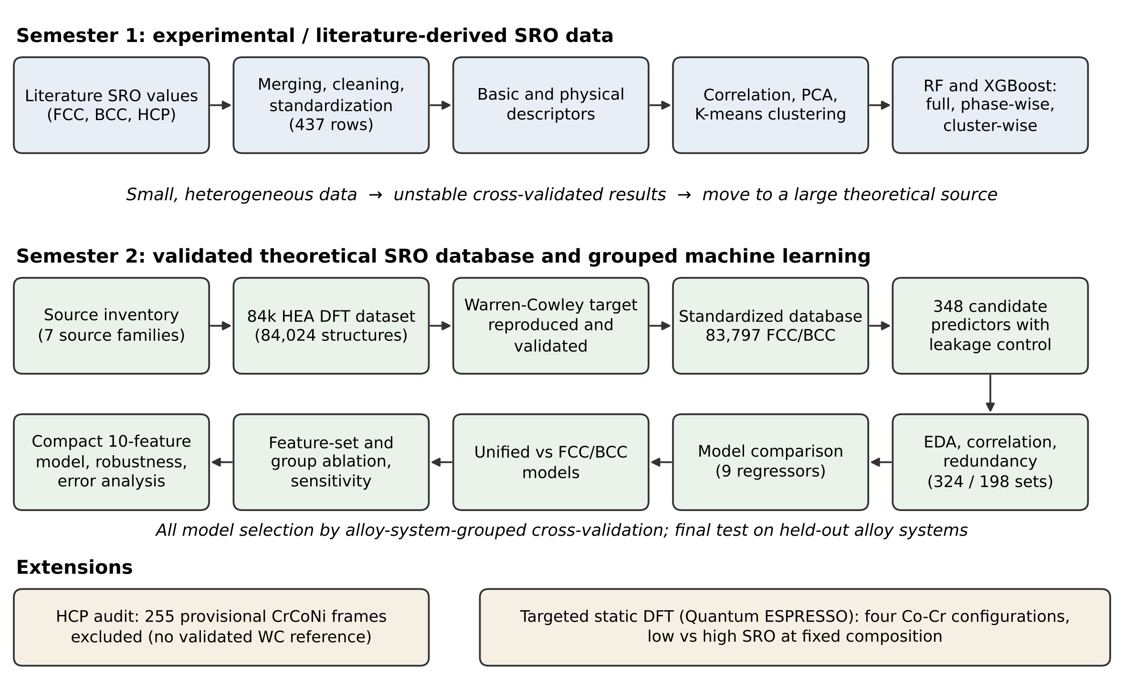
Figure 1. Overall workflow of the two-semester UGP. The extensions (bottom row) were kept separate from the validated FCC/BCC machine-learning study.

2.2 First-semester experimental data and ML workflow
The first-semester data were extracted manually from published papers into separate FCC, BCC and HCP sheets, which were then merged into one table while keeping the crystal-structure label. Extraction-related columns such as record IDs, paper names, URLs and notes were removed. Missing-value markers such as “NR” were cleaned, compositions were converted into numerical fractions, shell labels into shell numbers, and temperatures into kelvin. Table 1 gives the final phase distribution.
Table 1. Phase-wise distribution of the cleaned first-semester experimental SRO dataset.
Crystal structure | No. of rows | Example alloy systems
FCC | 331 | Cu–Zn, Ni–Ti, Ni–Cr, Ag–Al
BCC | 24 | Fe–Al, Fe–Cr
HCP | 82 | Ag–Al
Total | 437 | –

The dataset was clearly unbalanced: FCC made up about 76% of the rows, while BCC had only 24 rows. The ML workflow had three stages. First, RF and XGBoost regressors were trained on the full dataset with the minimal feature set. Second, the physical descriptors were added (mixing enthalpy, configurational entropy, electronegativity- and atomic-radius-based descriptors and size mismatch). Third, models were trained separately for each crystal structure and for K-means clusters, and the most promising FCC cluster was tested with multi-fold cross-validation. Model quality was measured mainly by R² and the root-mean-square error (RMSE) on a held-out test split. Representative literature-derived records and their source information are provided in Appendix A.

2.3 Theoretical data-source inventory
At the start of the second semester we made an inventory of the theoretical and software sources that could provide SRO data. Seven source families were collected locally, containing 46,123 files (about 10.1 GB). Most are repeated simulation outputs, potential files, plots and scripts, not independent observations. Each source was checked for its SRO convention, phase, temperature, pair and shell information, structure availability and the independence of its records. Table 2 summarizes the decision for each source.
Table 2. Theoretical SRO source inventory and incorporation decision.
Source | Method | Phases | Usable SRO records | Decision
84k HEA DFT dataset [7, 8] | DFT | FCC, BCC | 83,797 validated | Used for all ML
Rao–Curtin analytical SRO [9] | Analytical models + MC | FCC, BCC | Not normalized | Not integrated (abstract species)
MLP-cSRO CrCoNi [11] | ML potential, DFT-MC | FCC, HCP, liquid | 255 provisional HCP | HCP audit only
cSRO_lattice CrCoNi | ML potential MC/MD | FCC (likely) | Not normalized | Not integrated (correlated trajectories)
CrCoNi ColabFit [12] | DFT | Unresolved | 1,257 structures, no SRO | Not integrated
CMS-EAM [10] | EAM + MC | FCC, BCC, HCP | Incomplete outputs | Not integrated
HEA computational toolkit [14] | Software | FCC/BCC/HCP capable | 0 data rows | Reference only

Only the 84k dataset supplied a complete, one-to-one table of initial structures, structure descriptors and SRO values at the required scale. The other sources were not used because of unresolved conventions, missing SRO labels, correlated trajectories, abstract species, incomplete outputs or missing HCP reference data. These were decisions about scientific data quality rather than data-cleaning failures.

2.4 Primary 84k dataset
The selected source is a public DFT dataset of high-entropy-alloy structures published by Li et al. [7] and archived on Zenodo [8]. It contains 84,024 structures from 253 chemical systems built from Al, Co, Cr, Cu, Fe, Mn, Ni and Si. The structures include small ordered cells with up to 8 atoms and special quasi-random structures (SQS) with 27, 64 or 125 atoms. The source provides initial (unrelaxed) and final (relaxed) structures, DFT energies and other outputs, Matminer structure descriptors [15] for the initial and final structures, and a separate table of SRO summary statistics computed from the initial structures.
Exactly 227 records have no initial structure/lattice label and no matching SRO row. Removing them leaves 83,797 configurations with a complete one-to-one match between initial-structure features and SRO values (Table 3). These are 83,797 computational configurations, not 83,797 independent experiments: many of them share the same chemistry and were produced by the same configuration-generation procedure.
Table 3. Size and phase coverage of the theoretical database.
Quantity | Value
Structures in the original 84k source | 84,024
Records without initial structure / SRO | 227
Validated configurations used for ML | 83,797
FCC configurations | 40,425
BCC configurations | 43,372
Validated HCP configurations | 0
Alloy systems in the validated set | 246
Distinct compositions in the validated set | 9,633

2.5 SRO target definition and validation
The source publication and repository describe the SRO columns only briefly and do not include the script that produced them. Before modelling, we therefore checked their exact meaning by recalculating Warren-Cowley parameters (Equation 1.1) directly from the supplied initial cells and comparing them with the stored values; the recalculation reproduced the file values. For each configuration and each of the first four shells, the source computes α_{ij} for every unique unlike-element pair and then stores only summary statistics (mean, maximum, minimum, standard deviation and range of the signed and absolute values). The individual pair identities and coefficients are not stored.
The ML target used in this thesis is target_mean_abs_sro_shell1:
SRO₁ = (1 / N_{p}) Σ_{i<j} | α_{ij}⁽¹⁾ | (2.1)
where the sum runs over the N_{p} = k(k − 1)/2 unique unlike pairs of a configuration with k elements. In simple words, it is the mean absolute first-neighbour Warren-Cowley coefficient across all unlike-element pairs in one configuration. Taking the absolute value prevents positive and negative coefficients from cancelling each other, so the target measures how far the first shell is from random mixing. However, it is an aggregate magnitude: it is not pair-specific, it does not keep the sign (ordering versus avoidance), and it is not a temperature-dependent equilibrium SRO, because the source configurations have no annealing temperature. Two configurations with very different pair-level ordering can have the same target value.

2.6 Data standardization and quality control
The raw tables were converted into a standardized database. Compositions were stored as canonical element fractions, alloy-system labels were generated from the sorted element list (for example Co-Cr-Fe-Mn-Ni), and phase labels were normalized to FCC and BCC. The SRO table was reshaped into a long format with one row per configuration and shell (335,188 rows for four shells). The structure, feature and SRO tables were joined using exact one-to-one keys. All 83,797 configurations passed the join, there were no duplicate configuration IDs, and the final predictor matrix had no missing values.
Table 4 shows a few rows of the processed data to illustrate the format. The first four rows are the Co-Cr configurations later used in the DFT extension, and the last two are taken from the saved model-output tables. This is only an illustrative sample and not the statistical basis of the study; the full table has 83,797 rows and several hundred columns.
Table 4. Illustrative sample of the processed database (selected columns only).
Configuration ID | Phase | Alloy system | Composition (atomic fraction) | Atoms per cell | Target SRO
gra62121526 | FCC | Co-Cr | Co 0.50, Cr 0.50 | 2 | 0.0000
gra62121527 | FCC | Co-Cr | Co 0.50, Cr 0.50 | 2 | 0.3333
gra64001864 | BCC | Co-Cr | Co 0.50, Cr 0.50 | 2 | 0.0000
gra62121595 | BCC | Co-Cr | Co 0.50, Cr 0.50 | 2 | 1.0000
gra66931524 | FCC | Al-Cu-Ni-Si | Al 0.17, Cu 0.33, Ni 0.33, Si 0.17 | 6 | 0.1667
ced42006179 | BCC | Al-Co-Cr-Fe-Mn-Ni | Al 0.125, Co 0.125, Cr 0.125, Fe 0.25, Mn 0.25, Ni 0.125 | 8 | 0.1333

2.7 Feature engineering
A library of 348 candidate numerical predictors was built. Some were taken directly from the source (initial-structure Matminer descriptors) and others were calculated by us from the composition and from elemental reference data. The main feature families were:
- composition: element fractions, number of components, composition norms and 36 pair-fraction descriptors;
- configurational entropy: ideal mixing entropy (in J mol⁻¹ K⁻¹ and per atom) and a normalized form;
- atomic number and atomic mass: composition-weighted mean, deviation and range;
- atomic size: covalent-radius statistics and atomic-size mismatch;
- electronegativity: composition-weighted statistics and pair differences;
- VEC and electronic descriptors: valence electron concentration and counts of valence and unfilled electron states;
- melting point: composition-weighted statistics;
- initial structural geometry: packing efficiency, neighbour-distance variation, bond-length and cell-size deviations and Voronoi coordination;
- symmetry: the space-group number of the initial cell;
- local differences: differences in elemental properties (valence and unfilled states, elemental space group, electronegativity, magnetic moment) between each site and its neighbours in the initial cell; and
- phase metadata: FCC or BCC label.
After removing constant and leakage fields, 324 predictors remained (FULL_CLEAN). A redundancy-controlled subset of 198 predictors (BALANCED) was then prepared for the main model comparison. Several smaller sets were used for ablation, as listed in Table 5.
Table 5. Feature sets used in the second-semester study.
Feature set | Predictors | Content / purpose
Candidate library | 348 | All engineered and source-supplied numerical predictors
FULL_CLEAN | 324 | Leakage-clean, non-constant library
BALANCED | 198 | Redundancy-controlled set used for the main models
COMPOSITION_ONLY | 204 | Composition and elemental-reference descriptors; no structure or phase
COMPOSITION_PLUS_PHASE | 205 | COMPOSITION_ONLY plus the phase label
COMPOSITION_PLUS_INITIAL_STRUCTURE | 320 | Composition plus initial structural, symmetry and local descriptors
MINIMAL_PRELIMINARY | 19 | Early portable set (poor predictive performance)
MINIMAL_COMMON | 18 | Phase-independent composition/elemental fields recommended for future databases
COMPACT_HIGH_PERFORMANCE | 10 | Compact set selected using training data only (Section 2.13)

2.8 Leakage control
Because the source also contains the results of DFT relaxations, special care was needed to avoid data leakage, that is, using information that would not be available at prediction time or that directly contains the answer. The default ML predictors excluded final or relaxed energies, final volumes, final space groups, final forces, pressures and magnetization, the relaxed structures and all descriptors computed from them, all SRO fields and any direct ordering-parameter proxies. Only initial (pre-relaxation) descriptors were allowed. Constant-feature filtering and scaling were fitted inside each scikit-learn pipeline on the training data only.
Initial structural descriptors are not post-relaxation outcomes, but they are configuration-sensitive. The SRO target is itself calculated from the initial atomic arrangement, so the geometry and symmetry of that arrangement can carry information about the occupation pattern. These descriptors were therefore kept, but their effect was tested separately by feature-set ablation, group removal and single-feature removal (Sections 3.8 and 3.10).

2.9 EDA and redundancy analysis
Exploratory data analysis (EDA) covered phase counts, element and alloy-system coverage, the number of components, target distributions and missing data. The association between each predictor and the target was screened with Pearson correlation (linear), Spearman rank correlation (monotonic) and mutual information (general dependence). These are screening statistics only and do not show cause and effect. Redundancy was checked by finding constant and near-zero-variance features, exact duplicate columns and highly correlated pairs (|r| ≥ 0.95). This was used to design the BALANCED set.

2.10 Machine-learning models
Nine regression models were compared: a median dummy baseline, linear regression, Ridge, ElasticNet, Random Forest, Extra Trees, Gradient Boosting, HistGradientBoosting and a support-vector regressor trained on a 10,000-row subset. All were implemented in scikit-learn [13]. Three cohorts were modelled: a unified FCC+BCC model, an FCC-only model and a BCC-only model. Performance was measured by the coefficient of determination (R²), the mean absolute error (MAE) and the RMSE of the target. XGBoost (used in the first semester) was not part of the final environment; HistGradientBoosting is a closely related method. The selected HistGradientBoosting model used learning rate 0.08, at most 150 iterations, 31 leaf nodes, L2 regularization 1.0, minimum 20 samples per leaf and random state 42 (other settings at scikit-learn defaults). The code, fixed seeds and split/group definitions are stored in the project repository (https://github.com/abhinavDev-iit/SRO_ML_UGP.git).

2.11 Validation strategy
Because many configurations share the same chemistry, the way the data are split has a large effect on the measured performance. Three outer splits were compared (Table 6). In the random configuration split, rows are assigned randomly, so very similar configurations of the same alloy can appear in both the training and test sets; this gives an optimistic baseline. In the composition-grouped split, all configurations with the same composition are kept together, so the test compositions are unseen. In the alloy-system-grouped split, all configurations of a chemical system (for example every Co-Cr-Ni configuration) are kept together, so complete alloy systems are unseen during training. The alloy-system split is the main evaluation in this thesis.
Table 6. Outer validation splits (seed 42).
Split | Grouping column | Train rows | Test rows | Train / test groups | Group overlap
Random configuration | none | 67,037 | 16,760 | – | not applicable
Composition-grouped | composition | 68,318 | 15,479 | 7,706 / 1,927 | 0
Alloy-system-grouped (main) | chemical system | 71,117 | 12,680 | 196 / 50 | 0

Within the outer training partition, model and feature-set selection was performed using three-fold alloy-system-grouped cross-validation (GroupKFold, called grouped CV in this thesis). The fixed outer test partition was not used to alter the selected model or feature set. Outer-test metrics of the screened configurations are reported later only for final comparison. The primary reported pipeline therefore remains the configuration selected by grouped CV rather than the model giving the largest outer-test score. The alloy-system split tests generalization to new element combinations inside the Al-Co-Cr-Cu-Fe-Mn-Ni-Si domain; it does not test extrapolation to elements that are absent from the dataset.

2.12 Feature ablation and interpretation
Three kinds of tests were used to understand which information the models use. (i) Feature-set ablation compared the sets in Table 5. (ii) Physical-group ablation removed one whole descriptor family (symmetry, structural geometry, configurational entropy, electronic/VEC/periodic, composition, atomic size, electronegativity or elemental thermophysical) from BALANCED, retrained the model and recorded the change in grouped-CV R². (iii) Configuration-descriptor sensitivity removed the initial space-group number, the packing efficiency, the neighbour-distance variation, the whole structural-geometry group or the whole symmetry group and measured the change in the outer-test R². Permutation importance on the held-out set was also calculated. These methods describe what the fitted model relies on; they do not prove a physical mechanism.

2.13 Compact model selection
To find a smaller model, feature counts of 10, 20, 30, 50, 75, 100, 150 and 198 were tested. Inside the outer training partition, features were ranked using a further group split of the training data only, and each subset size was evaluated with grouped inner CV. The smallest size whose mean CV R² stayed above an acceptance threshold of 0.8503 (0.03 below the BALANCED value of 0.8803) was chosen. The outer test set was not used during this selection.

2.14 HCP audit
Since the first-semester dataset contained 82 HCP rows, we also searched for theoretical HCP SRO data. The MLP-cSRO CrCoNi source [11] contains 255 provisional HCP configurations (144-atom frames associated with five 500 K Monte Carlo trajectories). We tried to validate their first-shell WC values, but the authors’ HCP Warren-Cowley reference arrays and the exact ideal-HCP shell/topology mapping were not available in the checked repositories. A simple distance-ranked reconstruction was not accepted, because 98 of the 255 frames have a ratio of the 13th- to 12th-neighbour distance below 1.02, which makes the first-shell boundary ambiguous. As a quality-control decision, these frames were kept out of the ML database.

2.15 DFT extension methodology
As a small extension of the ML study, we carried out static first-principles calculations on four configurations from the validated database. We selected two FCC and two BCC Co-Cr configurations with the same composition (Co 0.5, Cr 0.5) and the same cell size (2 atoms), one with low and one with high target SRO in each phase. Within each pair, the two source cells differ in their initial cell shape and symmetry as well as in their SRO label. The exact initial cells and fractional coordinates from the source were used.
The calculations were performed with Quantum ESPRESSO 7.6 (pw.x) [16, 17] using spin-polarized PBE [18] and SSSP Efficiency pseudopotentials for Co and Cr [19]. The plane-wave cutoffs were ecutwfc = 55 Ry and ecutrho = 440 Ry, the Brillouin zone was sampled with a 12 × 12 × 12 Monkhorst-Pack grid [20], and Marzari-Vanderbilt smearing [21] with degauss = 0.02 Ry was used. The SCF threshold was conv_thr = 10⁻⁸ Ry. Only static SCF calculations were performed; no ionic or cell relaxation was done. A cutoff check on one structure showed an energy change of only 1.77 meV/atom between 55 and 65 Ry. Energies were normalized per atom and compared only within each fixed-composition phase pair.
Chapter 3

Results and Discussion

3.1 Semester-1 findings and limitations
The first result of the first semester was a clean experimental SRO dataset in one consistent format. The correlation heat map (Figure 2) showed that some composition and phase variables were strongly related to each other, for example Fe and Cr with the BCC phase and Al and Ag with the HCP phase. This mainly reflects which alloys had been studied in each phase rather than a physical rule. No single variable explained the SRO value.
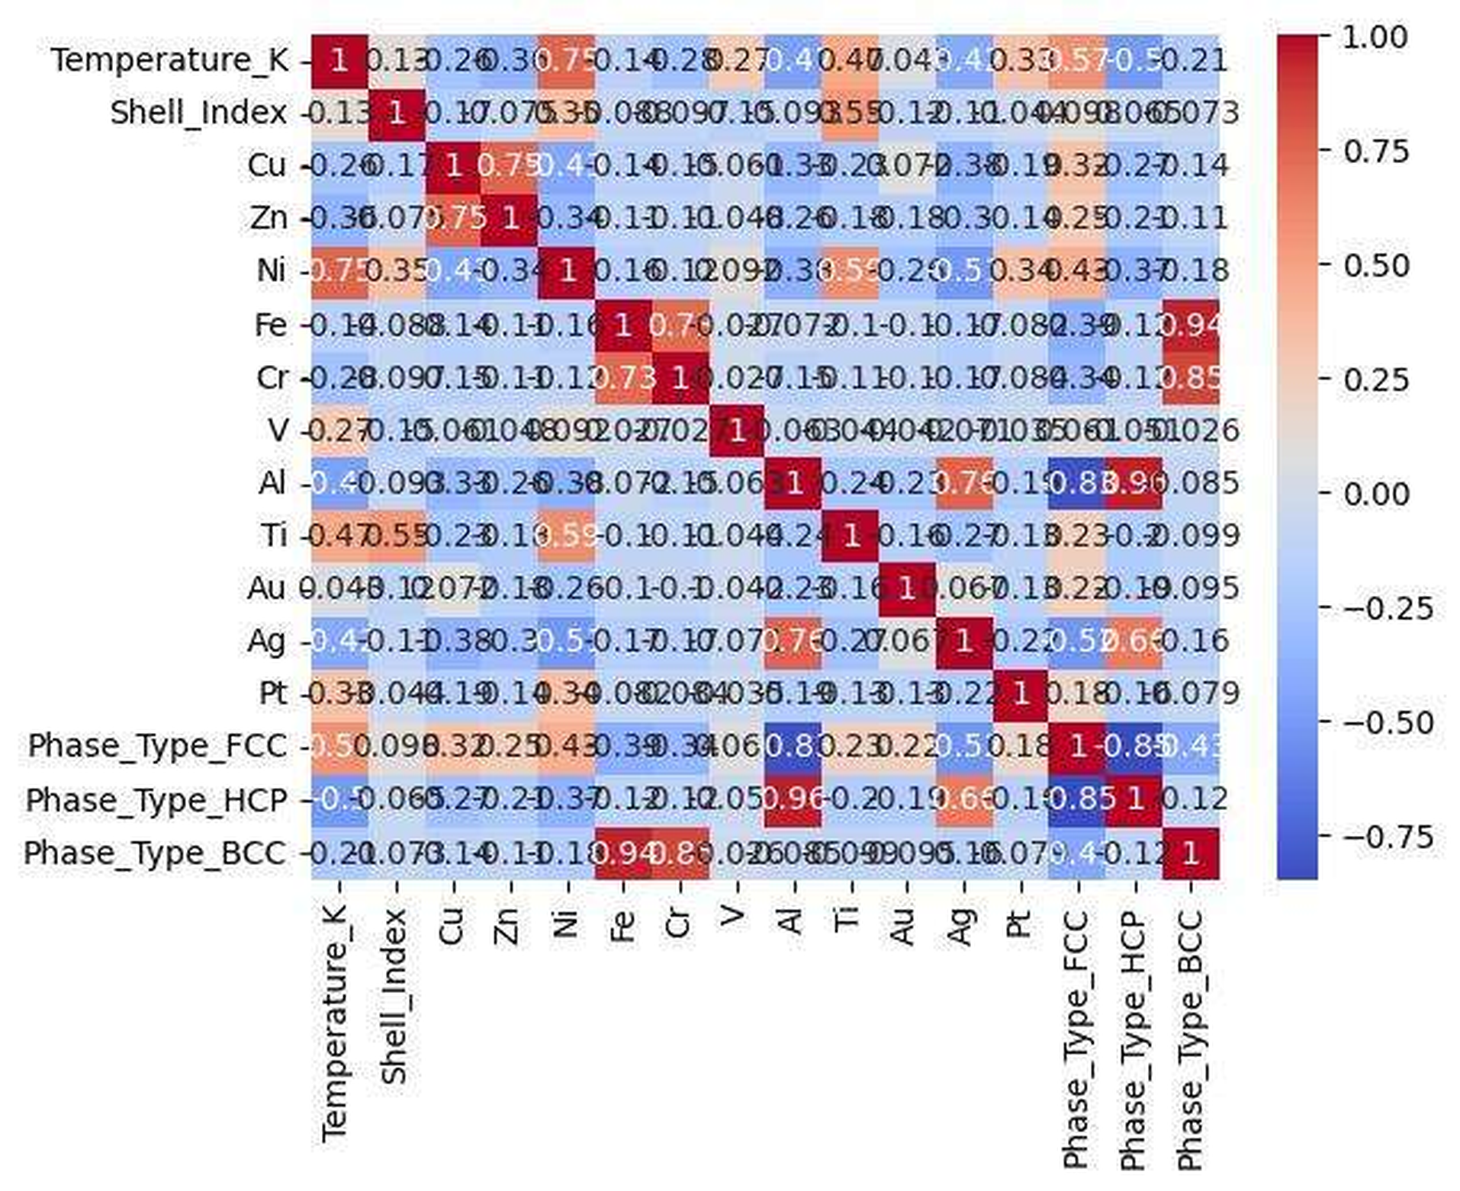
Figure 2. Correlation heat map of the processed first-semester features and the SRO value. Reproduced from the first-semester report.
PCA and K-means clustering (Figure 3) showed that the clusters in the full dataset were mainly controlled by elemental composition, and training models on these clusters did not improve prediction. Phase-wise modelling was more useful: FCC models were clearly better than models on the mixed dataset, while BCC and HCP models were weak because of their small size. Inside the FCC subset, one cluster of 164 Ni-rich, higher-temperature observations gave the best single-split result. Table 7 summarizes the main results.
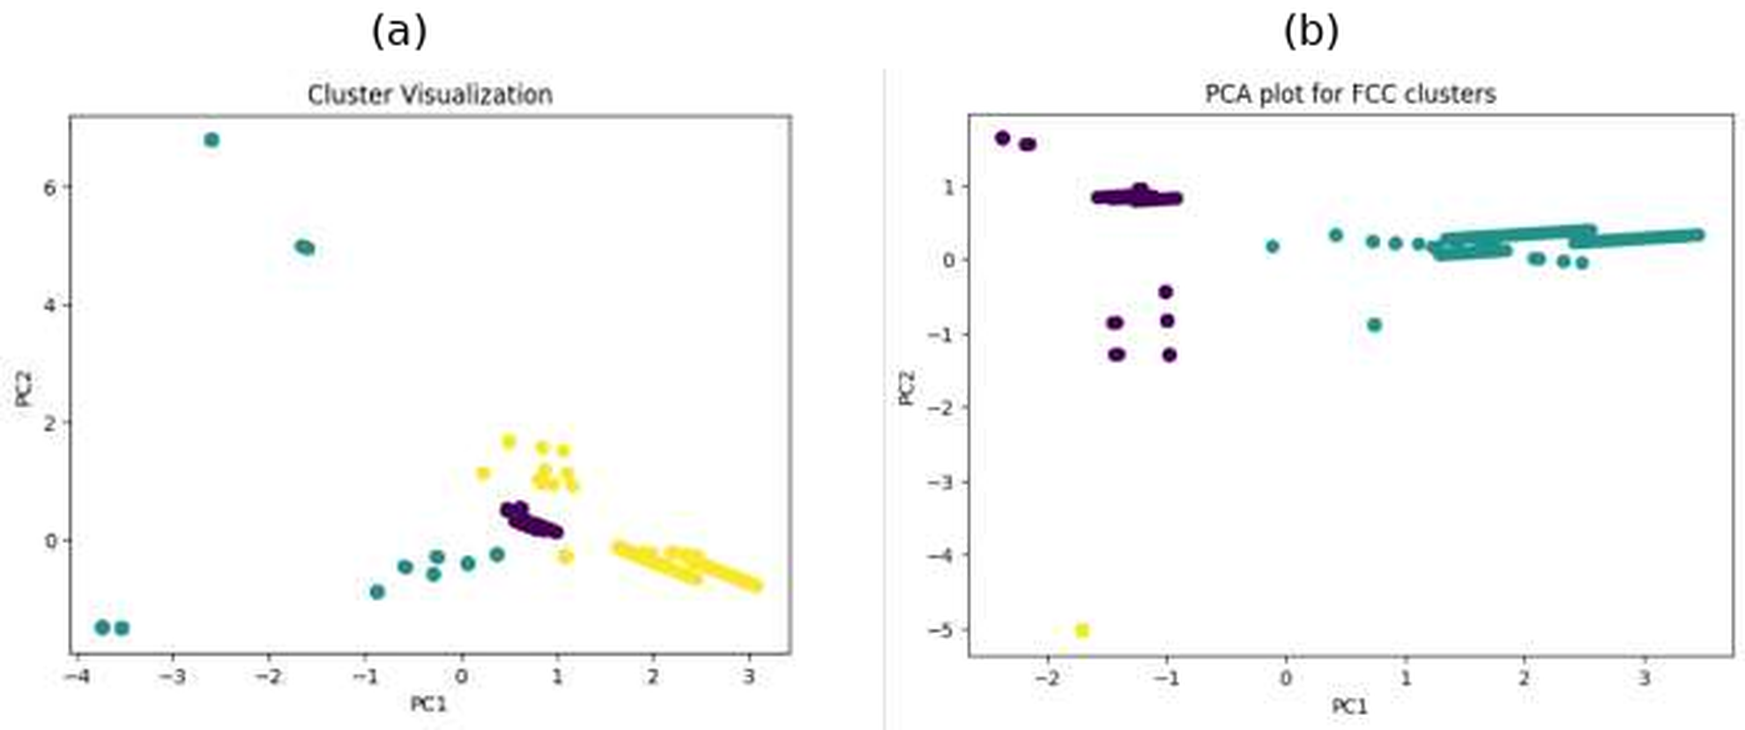
Figure 3. PCA visualization of K-means clusters: (a) full first-semester dataset; (b) FCC subset. From the first-semester report.
Table 7. Main first-semester machine-learning results.
Study | Dataset / subset | Model | R² | RMSE
Full dataset | All phases | Random Forest | 0.349 | 0.133
Full dataset | All phases | XGBoost | 0.356 | 0.132
Phase-wise | FCC | Random Forest | 0.510 | 0.121
Phase-wise | FCC | XGBoost | 0.660 | 0.101
FCC cluster-wise | FCC cluster 1 | Random Forest | 0.740 | 0.090
FCC cluster-wise | FCC cluster 1 | XGBoost | 0.715 | 0.094
FCC cluster validation | FCC cluster 1 (5-fold CV) | Random Forest | 0.337 (mean) | –

The key observation is the last row. The R² of 0.740 came from one favourable split; with five-fold cross-validation the mean R² fell to 0.337, with large variation between folds. With 437 rows spread over many alloy systems, temperatures, shells and three phases, a few test rows can change the score a lot. The first semester therefore showed that ML can reveal trends in experimental SRO data, but that stable prediction needed a much larger and more uniform dataset. This led directly to the second-semester work.

3.2 Final theoretical dataset
The final validated database contains 83,797 configurations: 40,425 FCC and 43,372 BCC (Figure 4). The 255 provisional HCP frames are shown only to make their exclusion visible. The configurations cover 246 alloy systems and 9,633 distinct compositions. Fe, Mn, Co, Ni and Cr each appear in about 53,000 configurations, while Al, Si and Cu appear in 24,868, 24,450 and 16,154 configurations respectively. Most configurations are ternary or quaternary, and the most represented system is Co-Cr-Fe-Mn-Ni with 5,107 configurations. Because many rows share chemistry, the number of rows is much larger than the number of independent chemical groups, which is why grouped validation was needed.
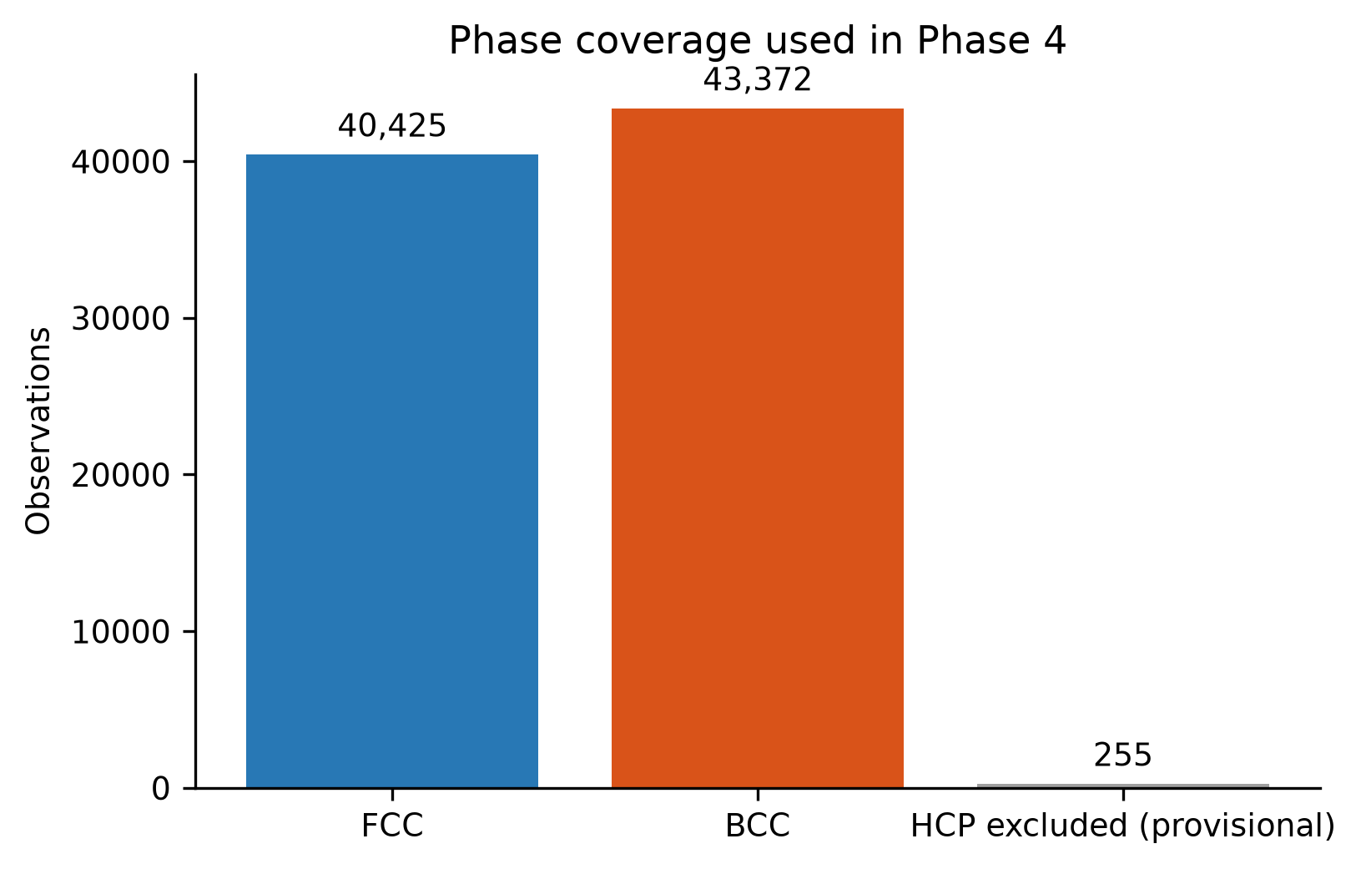
Figure 4. Validated phase coverage of the theoretical database. The 255 provisional HCP configurations are shown only to indicate their exclusion.

3.3 SRO distribution
The target ranges from 0 to 1.5, with an overall mean of 0.3345 and a median of 0.2708 (Figure 5). The distribution is right-skewed (skewness 1.106) and has a peak at zero, since 7,278 configurations have exactly random first-shell occupation. The FCC mean is 0.2640 (median 0.2222) and the BCC mean is 0.4002 (median 0.3333). The distributions show discrete peaks because small ordered cells allow only a few possible neighbour counts. The 1,036 Tukey outliers were kept because they are bounded, physically possible SRO values rather than errors.
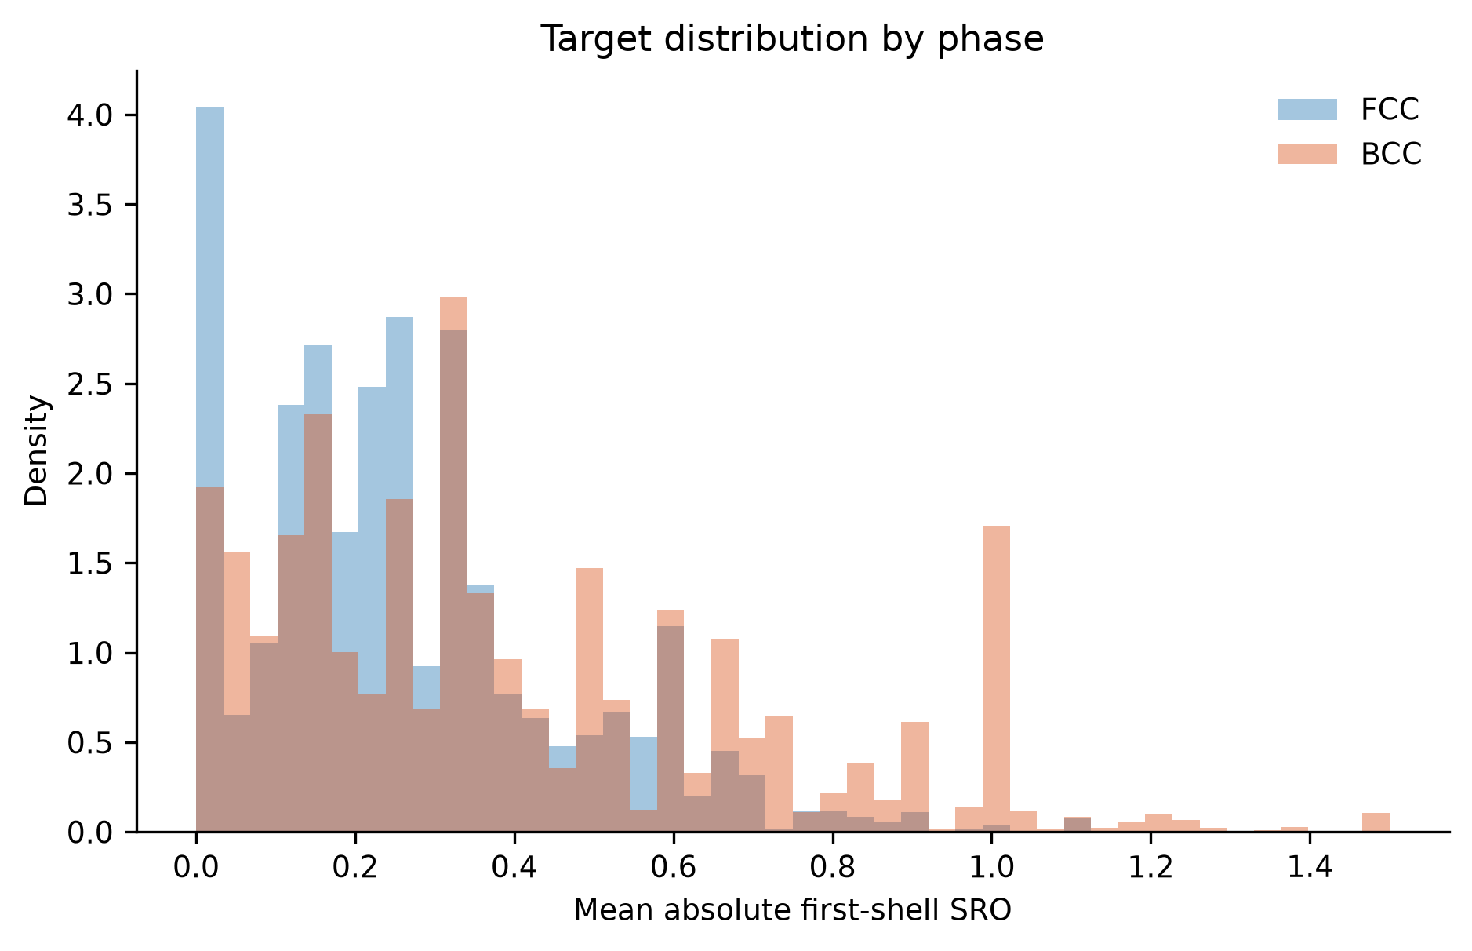
Figure 5. Distribution of the aggregate first-shell SRO magnitude for FCC and BCC configurations.

3.4 Main correlations and redundancy
Figure 6 shows the predictors with the strongest monotonic association with the target. The initial space-group number has the largest association (Spearman ρ = 0.5931, Pearson r = 0.4753), followed by the number of atoms in the cell (NIONS, ρ = −0.3260), composition norms and configurational entropy (ρ = 0.2714). The largest mutual-information value was 1.7996 for the composition 5-norm, with configurational entropy close behind (1.7979). The strongest simple associations therefore come from the symmetry and size of the cell and from the composition complexity. These are associations within this dataset: the space-group number reflects how the ordered or SQS cells were constructed and does not mean that the space group causes SRO.
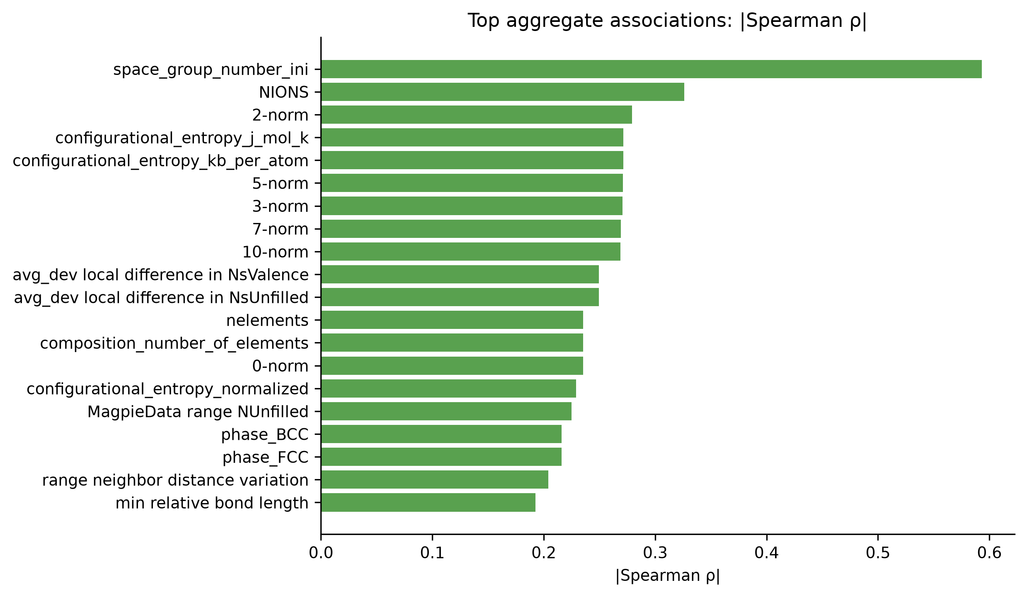
Figure 6. Predictors with the largest absolute Spearman rank correlation with the target (all configurations).
The redundancy check found 24 constant features, 29 near-zero-variance features, nine groups of exactly duplicated columns and 426 feature pairs with |r| ≥ 0.95. This redundancy comes mainly from composition constraints, alternative summary statistics of the same property and physically related properties. Removing these predictors, which mostly repeated information already present rather than being physically unimportant, gave the 198-feature BALANCED set.

3.5 Model comparison
Table 8 lists the leading unified configurations ranked by grouped-CV R², which was the selection criterion, and Figure 7 shows the outer-test R² of all screened configurations for comparison. Tree ensembles (HistGradientBoosting, Random Forest and Extra Trees) performed far better than the linear models, which reached only about 0.66 grouped-CV R². This indicates strongly non-linear relations between the descriptors and the SRO magnitude. Standard Gradient Boosting with default settings performed poorly (CV R² = 0.5072), and the dummy baseline had an R² close to zero.
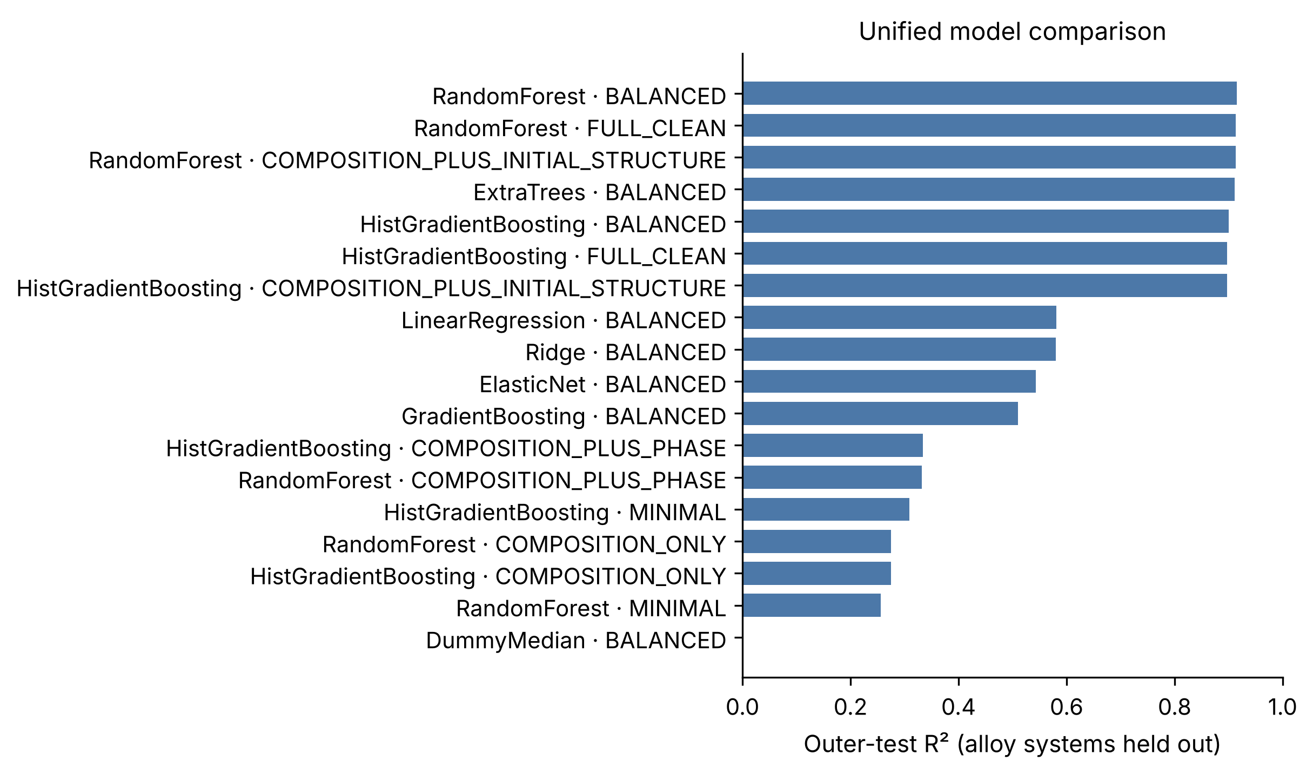
Figure 7. Outer-test R² of all screened unified model and feature-set combinations. Shown for comparison only; model selection used grouped CV.
HistGradientBoosting with the BALANCED set had the highest grouped-CV R² (0.8803) and was therefore selected; the same configuration was also selected for the FCC and BCC cohorts. On the outer alloy-held-out test, Random Forest obtained a slightly higher R² (0.9151 versus 0.8997) and a lower MAE. Random Forest was not selected retrospectively after observing these test results, because that would amount to selecting the model on the test set and would make the reported score optimistic. In the rest of this thesis, the selected model means this CV-selected HistGradientBoosting pipeline. The difference between the leading tree models is small compared with their difference from the linear models.
Table 8. Unified models ranked by grouped-CV R² (selection criterion); outer-test values shown for comparison.
Model | Feature set | Features | Grouped-CV R² | Test R² | Test MAE | Test RMSE
HistGradientBoosting | BALANCED | 198 | 0.8803 | 0.8997 | 0.0535 | 0.0764
HistGradientBoosting | FULL_CLEAN | 324 | 0.8783 | 0.8973 | 0.0539 | 0.0774
HistGradientBoosting | COMP. + INITIAL STRUCT. | 320 | 0.8783 | 0.8970 | 0.0543 | 0.0775
Random Forest | BALANCED | 198 | 0.8712 | 0.9151 | 0.0422 | 0.0703
Random Forest | FULL_CLEAN | 324 | 0.8695 | 0.9128 | 0.0409 | 0.0713
Extra Trees | BALANCED | 198 | 0.8695 | 0.9115 | 0.0450 | 0.0718
Ridge | BALANCED | 198 | 0.6633 | 0.5802 | 0.1183 | 0.1564
Linear regression | BALANCED | 198 | 0.6629 | 0.5810 | 0.1183 | 0.1562
ElasticNet | BALANCED | 198 | 0.6199 | 0.5428 | 0.1230 | 0.1632
Gradient Boosting | BALANCED | 198 | 0.5072 | 0.5099 | 0.1294 | 0.1690
Median dummy | BALANCED | 198 | −0.0571 | 0.0000 | 0.1842 | 0.2414

3.6 Generalization under grouped splits
Table 9 gives the final metrics of the selected pipeline, and Figure 8 shows how R² changes with the type of split. For the unified model, R² decreases from 0.9266 for the random split to 0.9161 for unseen compositions and 0.8997 for unseen alloy systems, while MAE increases from 0.0508 to 0.0535. The same order is seen for FCC and BCC. This decrease is expected: the stricter the split, the less the model can rely on very similar training examples. The fall is fairly small, which shows that the model has learned patterns that carry over to new element combinations within this database, and is not only memorizing near-duplicate configurations.
Table 9. Results of the CV-selected HistGradientBoosting model (198 BALANCED predictors).
Evaluation | Train rows | Test rows | R² | MAE | RMSE
Unified, random configuration split | 67,037 | 16,760 | 0.9266 | 0.0508 | 0.0731
Unified, composition-grouped split | 68,318 | 15,479 | 0.9161 | 0.0534 | 0.0760
Unified, alloy-system-grouped split | 71,117 | 12,680 | 0.8997 | 0.0535 | 0.0764
FCC model, alloy-system-grouped split | 34,520 | 5,905 | 0.9058 | 0.0348 | 0.0534
BCC model, alloy-system-grouped split | 36,597 | 6,775 | 0.9154 | 0.0563 | 0.0808

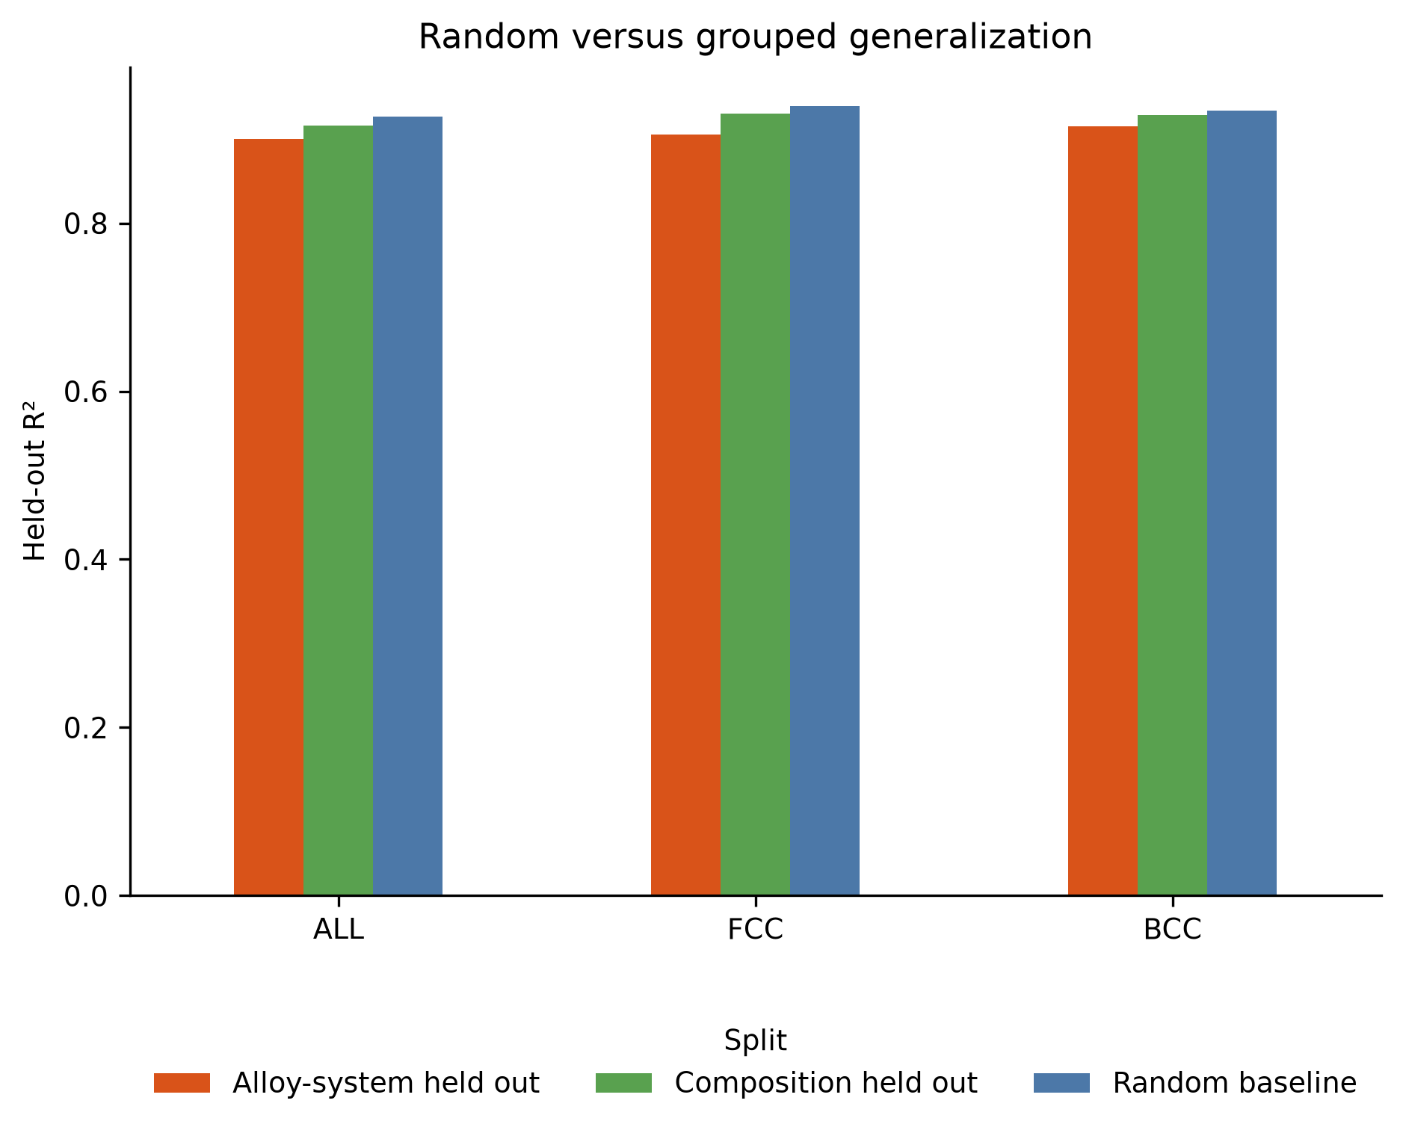
Figure 8. Held-out R² of the frozen CV-selected pipeline under random, composition-grouped and alloy-system-grouped splits.
Figure 9 compares observed and predicted values for the unified model on the 50 held-out alloy systems. Most points lie close to the diagonal. The spread grows at high SRO values, and the highest values are generally under-predicted, which is examined further in Section 3.12.
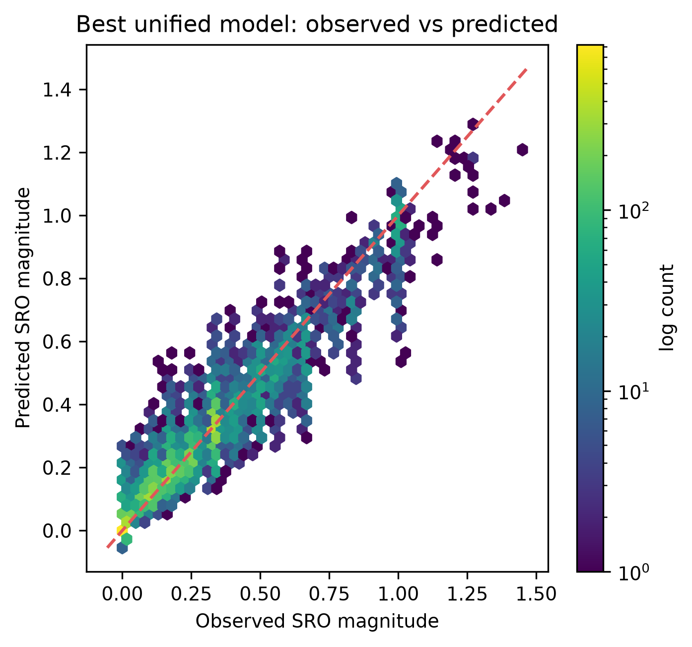
Figure 9. Observed versus predicted SRO magnitude for the unified model on held-out alloy systems. Colour shows the number of points in each hexagonal bin (log scale).

3.7 Unified versus phase-specific models
To compare unified and phase-specific models fairly, both were evaluated on exactly the same held-out FCC rows (5,905) and BCC rows (6,775). For FCC, the phase-specific model improved R² from 0.8668 to 0.9058 and reduced MAE from 0.0438 to 0.0348. For BCC, R² improved from 0.9038 to 0.9154 and MAE from 0.0621 to 0.0563. Figure 10 compares the overall unified result with the two phase-specific models. The gain is larger for FCC. Separate phase models therefore give the best accuracy and are more useful for phase-wise interpretation, while the unified model is a simpler single model with only a modest loss. This agrees with the first-semester observation that separating phases was helpful, but the conclusion is now supported by a much larger dataset and grouped validation.
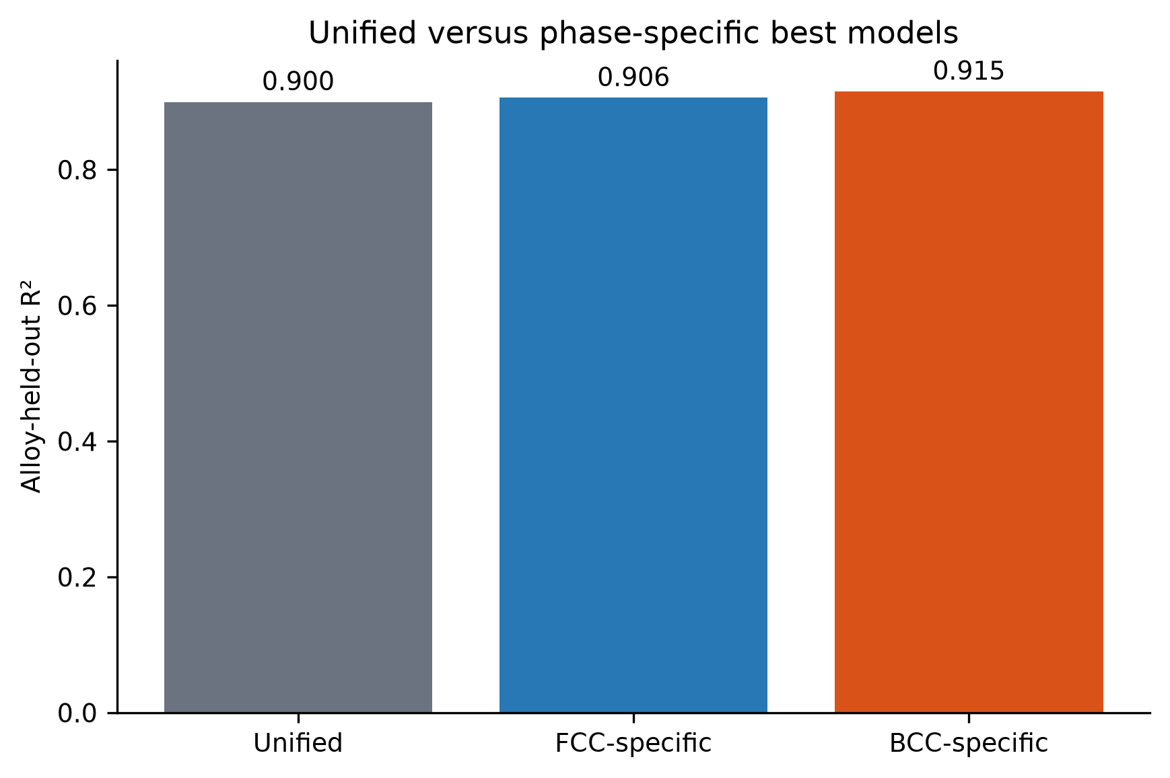
Figure 10. Alloy-held-out R² of the unified model and the FCC- and BCC-specific models.

3.8 Feature-set ablation
The feature-set ablation (Table 10 and Figure 11) is one of the central results of this thesis. With composition and elemental descriptors only, HistGradientBoosting reached a grouped-CV R² of just 0.0262. Adding the phase label raised it to 0.1764. Adding initial structural and symmetry descriptors to the composition features raised it to 0.8783, almost equal to the BALANCED set (0.8803). The 19-feature MINIMAL_PRELIMINARY set gave only 0.1008.
Table 10. Unified HistGradientBoosting feature-set ablation.
Feature set | Predictors | Grouped-CV R² | Test R² | Test MAE
COMPOSITION_ONLY | 204 | 0.0262 | 0.2745 | 0.1447
MINIMAL_PRELIMINARY | 19 | 0.1008 | 0.3089 | 0.1436
COMPOSITION_PLUS_PHASE | 205 | 0.1764 | 0.3339 | 0.1399
COMPOSITION_PLUS_INITIAL_STRUCTURE | 320 | 0.8783 | 0.8970 | 0.0543
FULL_CLEAN | 324 | 0.8783 | 0.8973 | 0.0539
BALANCED | 198 | 0.8803 | 0.8997 | 0.0535

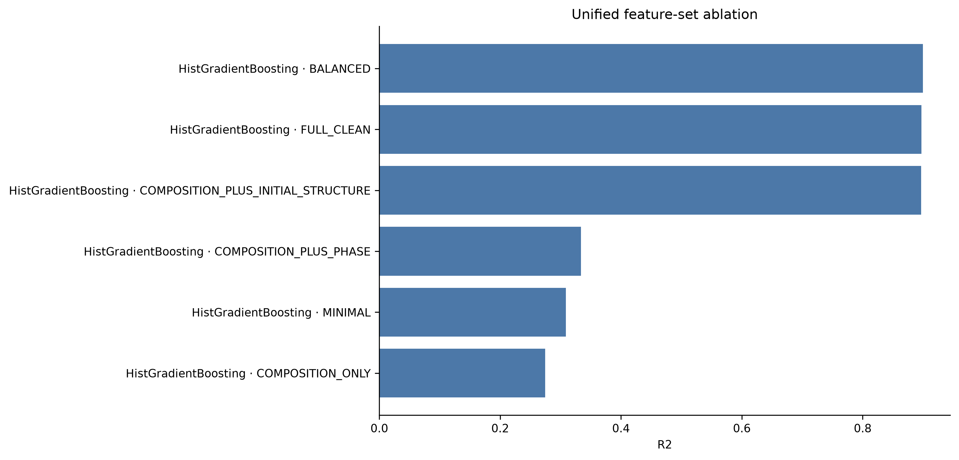
Figure 11. Alloy-held-out R² of HistGradientBoosting for different feature sets.
The main ML claim of this thesis must therefore be stated precisely. The project does not show that aggregate SRO can be predicted accurately from alloy composition alone. It shows that aggregate SRO magnitude can be predicted well when the initial pre-relaxation configuration and the descriptors derived from it are available. Configuration-sensitive initial structural information is essential for configuration-level prediction within this source. The result is reasonable, because the dataset contains many configurations of the same composition with different SRO values, and composition alone cannot tell them apart. However, it must be interpreted carefully. The initial structural and symmetry descriptors may partly encode the configuration-generation procedure, the identity of the ordered or SQS cell, the number of atoms and the initial topology. They are therefore highly predictive here, but they may not transfer unchanged to independent experimental datasets, where structures are not generated in the same way.

3.9 Compact model
The compact-model search (Figure 12) showed that grouped-CV R² was almost flat from 30 to 198 features (0.8776–0.8803). The smallest tested set, 10 features, had a mean CV R² of 0.8636 (SD 0.0290), which is above the acceptance threshold of 0.8503, and it was selected. The ten predictors are listed in Table 11.
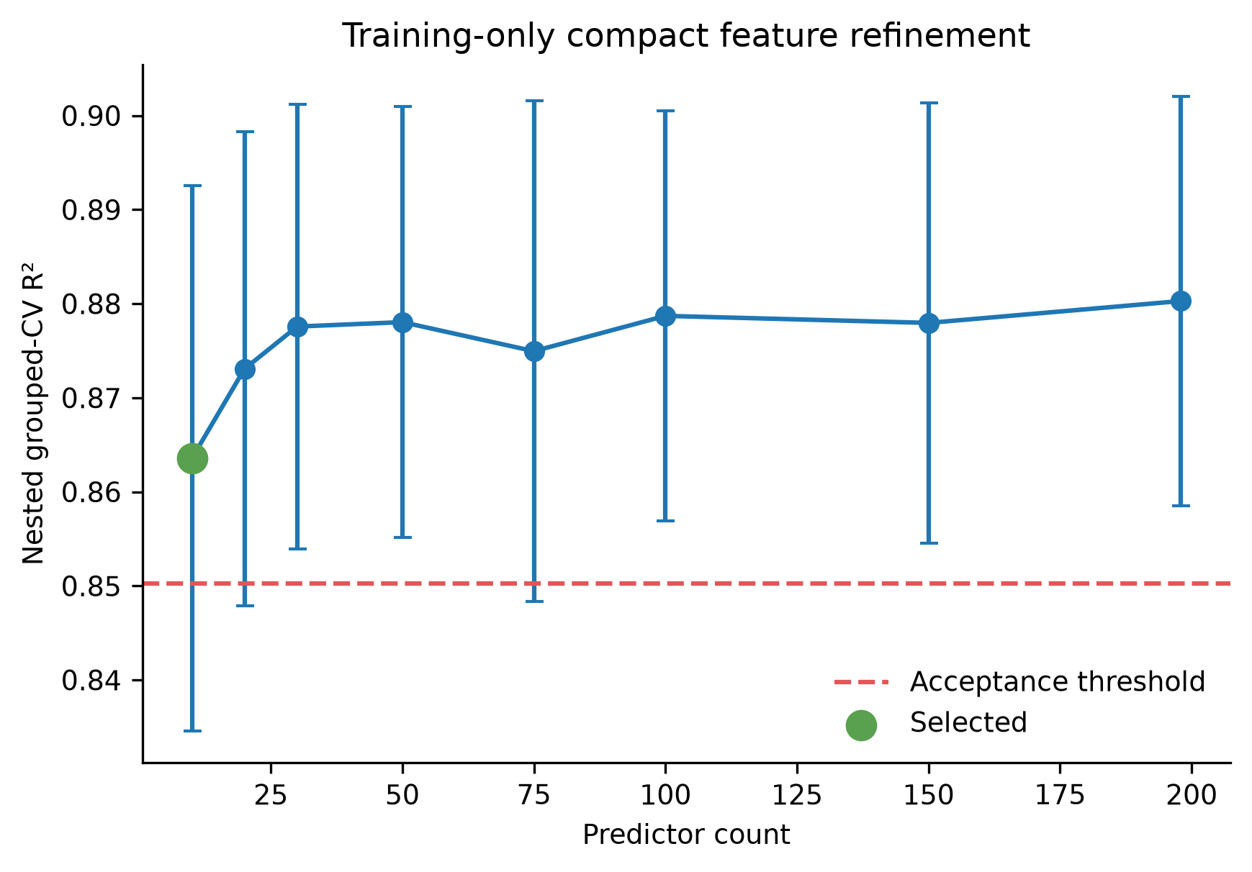
Figure 12. Training-only grouped-CV R² versus number of predictors used to select the compact model. Error bars show the standard deviation across folds; the dashed line is the acceptance threshold.
Table 11. Predictors of the compact 10-feature model.
No. | Predictor | Descriptor type
1 | space_group_number_ini | Initial symmetry
2 | configurational_entropy_j_mol_k | Configurational entropy
3 | max packing efficiency | Initial structural geometry
4 | NIONS | Cell size (atoms per cell)
5 | range neighbor distance variation | Initial structural geometry
6 | configurational_entropy_normalized | Configurational entropy
7 | minimum local difference in NsUnfilled | Local electronic difference
8 | mean local difference in SpaceGroupNumber | Local elemental difference
9 | mean local difference in NsValence | Local electronic difference
10 | avg_dev local difference in NsValence | Local electronic difference

On the untouched outer alloy-system test, the compact unified model achieved R² = 0.8917, MAE = 0.0537 and RMSE = 0.0794, only 0.0081 below the 198-feature BALANCED model. The compact FCC and BCC models gave R² = 0.9038 and 0.9061. A twenty-fold reduction in the number of predictors therefore costs very little accuracy. However, eight of the ten predictors are derived from the initial cell (symmetry, packing, atom count, neighbour-distance variation and local site differences), and the remaining two are configurational-entropy descriptors. The compact set is a good model for the current source, but it is not a universal, transferable descriptor set. For future databases that combine different sources, we recommend recording the 18-feature MINIMAL_COMMON set of composition and elemental descriptors together with clear provenance and SRO-convention information.

3.10 Feature interpretation
The permutation importance of the unified model (Figure 13) is dominated by the initial space-group number, followed by configurational entropy, maximum packing efficiency and NIONS. The same top predictors appear in the FCC and BCC models. Because correlated features can share importance, physical-group ablation is easier to interpret (Figure 14). In the unified model, removing the symmetry group reduced grouped-CV R² by 0.0666, structural geometry by 0.0246, configurational entropy by 0.0220 and the electronic/VEC/periodic group by 0.0126. Removing the composition, atomic-size, electronegativity or thermophysical groups changed R² by less than 0.005, because the remaining features still carried overlapping information.
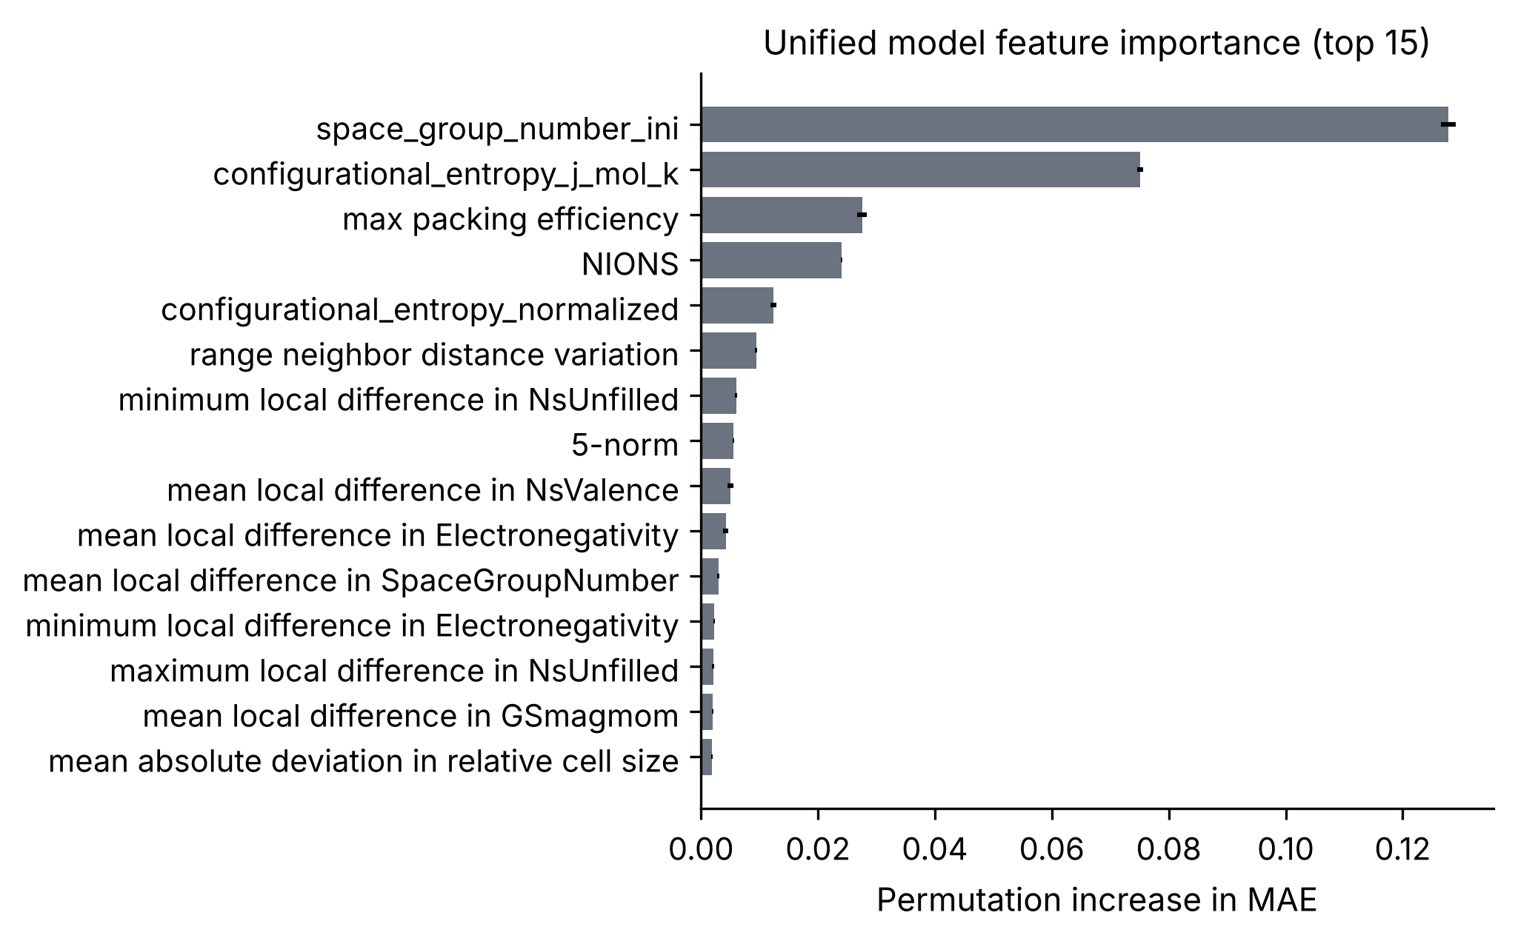
Figure 13. Permutation importance of the 15 most important predictors of the unified model on held-out alloy systems (increase in MAE).
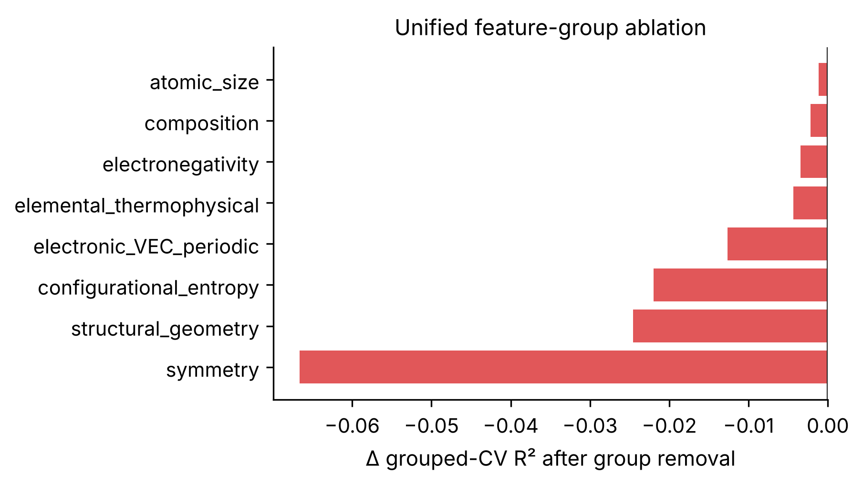
Figure 14. Change in unified grouped-CV R² after removing each physical descriptor group from BALANCED.
The configuration-descriptor sensitivity test (Figure 15) measured the effect on the outer test. Removing only the initial space-group number lowered R² by 0.0830 for the unified model, 0.0751 for FCC and 0.0805 for BCC. Removing the whole symmetry group lowered it by 0.0950, 0.0725 and 0.1000. Removing the packing efficiency reduced the unified R² by 0.0186, while removing the neighbour-distance variation had almost no effect (−0.0006) because related geometry descriptors remained. The symmetry signal is present inside each phase, so it is not just a hidden FCC/BCC label. It may combine real structural information with signatures of how the ordered and SQS cells were built. We therefore treat these descriptors as strong predictors within this workflow, not as causes of SRO.
Taken together, Sections 3.8 and 3.10 show that the predictive power of the models comes mainly from configuration information (the initial cell, its symmetry and local site environments) and much less from composition information. The importance and ablation results describe what the fitted models use for prediction; they do not show that these descriptors cause SRO.
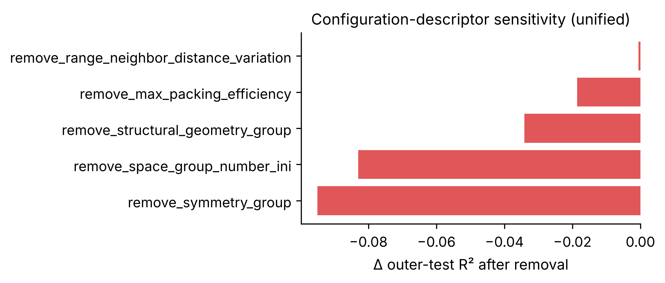
Figure 15. Change in unified outer-test R² after removing selected configuration-sensitive descriptors or descriptor groups.

3.11 FCC versus BCC behaviour
The BCC configurations have a higher aggregate SRO magnitude in this dataset. The mean target is 0.2640 for FCC and 0.4002 for BCC, a difference of 0.1362, with Cohen’s d = 0.5253 (a medium effect) and a Kolmogorov-Smirnov statistic of 0.2334 (Figure 5). This should not be read as proof that the BCC crystal structure itself causes stronger SRO, because the FCC and BCC subsets contain different mixtures of chemistries, cell sizes and configuration types.
In terms of predictability, the BCC model had the higher R² on the main split (0.9154 versus 0.9058), but its MAE was also higher (0.0563 versus 0.0348) because BCC targets are larger and more spread out. Across five repeated splits (Section 3.12) the mean R² values were almost identical (FCC 0.9046, BCC 0.9042), so neither phase can be called intrinsically easier to predict. Both phases rank the initial space group, configurational entropy, atom count and local electronic differences highly. FCC models give more weight to neighbour-distance and cell-size variation, while BCC models give more weight to differences in unfilled states, local space group, electronegativity and magnetic moment.

3.12 Robustness and error analysis
To check that the results do not depend on one lucky split, the alloy-system split was repeated with five deterministic group allocations (Table 12 and Figure 16). The mean unified R² of 0.8946 is close to the main result, and the lowest value over all cohorts and splits is still 0.8620. Performance therefore does not depend on one favourable seed. The BCC results vary more, so BCC accuracy depends more on which alloy systems are held out.
Table 12. Robustness over five deterministic alloy-system-held-out splits.
Cohort | Mean R² | SD | Minimum R² | Maximum R²
Unified (FCC+BCC) | 0.8946 | 0.0187 | 0.8671 | 0.9154
FCC | 0.9046 | 0.0128 | 0.8907 | 0.9193
BCC | 0.9042 | 0.0287 | 0.8620 | 0.9335

Error analysis of the 12,680 unified test predictions showed that the 95th-percentile absolute error was 0.1682, which defines 634 high-error rows. BCC rows had a higher MAE (0.0621) and high-error fraction (6.51%) than FCC rows (0.0438 and 3.27%). The error increases strongly with the target value (Figure 17): MAE rises from 0.0359 in the lowest target decile to 0.0915 in the highest, and the model tends to under-predict the largest SRO values. The held-out systems with the highest unified MAE included Co-Mn, Co-Mn-Ni and Fe-Mn-Ni, which were completely absent from training. No test value of the compact features lay outside the training range, and only 0.16–1.98% of test rows were outside the training 1st–99th percentile range of individual features. The main source of error is therefore difficult high-SRO configurations and unseen chemistries, rather than simple extrapolation in single features.
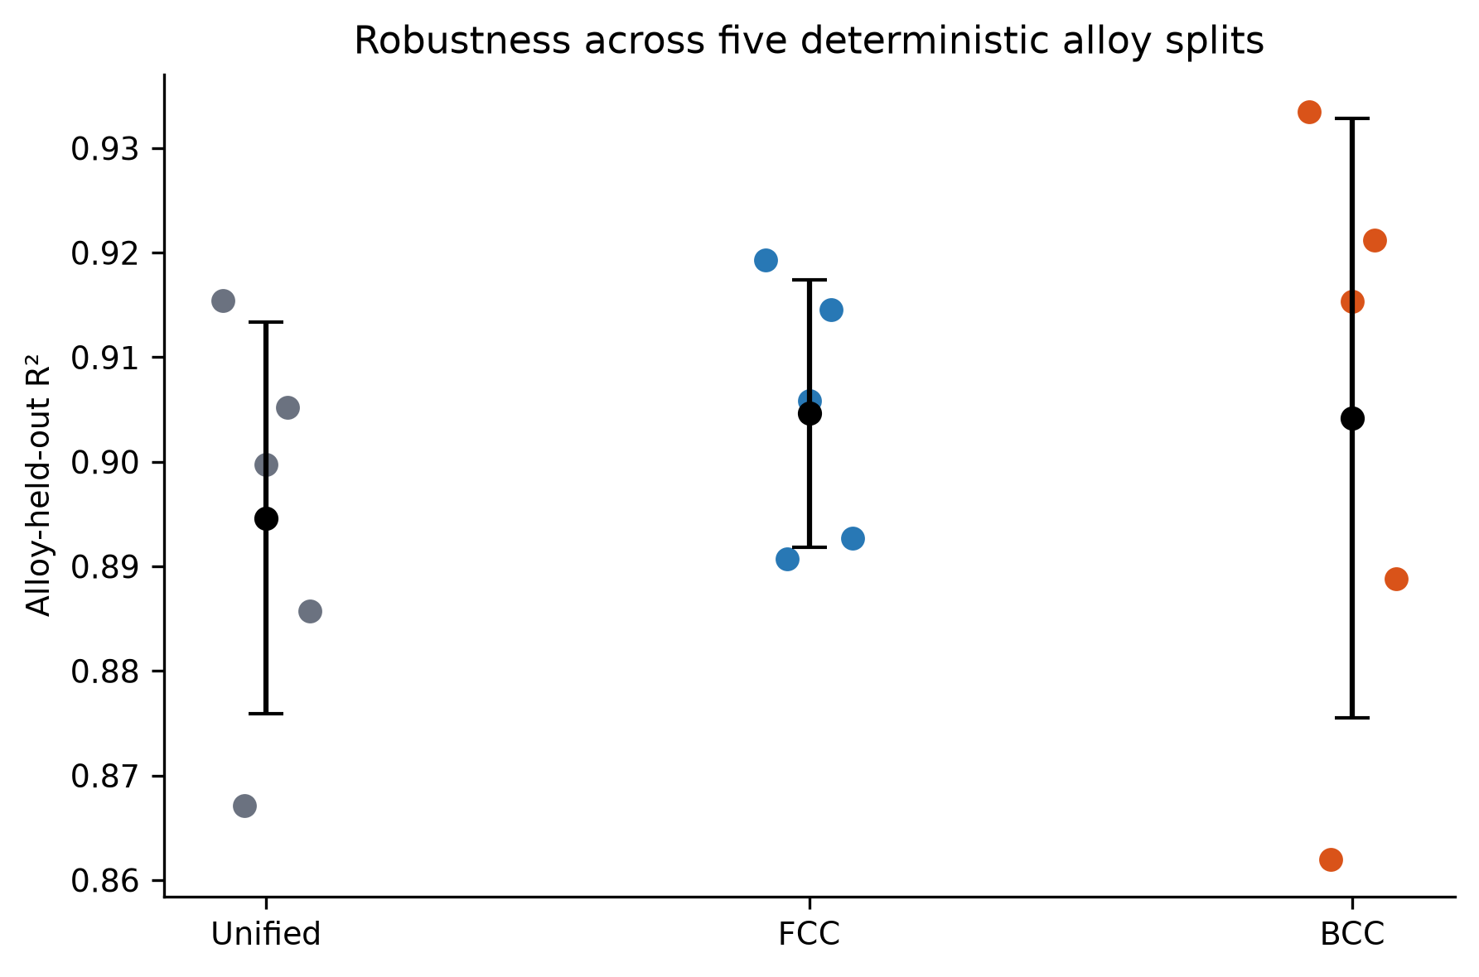
Figure 16. Alloy-held-out R² across five deterministic group allocations. Coloured points are individual splits; black points and bars show the mean and standard deviation.
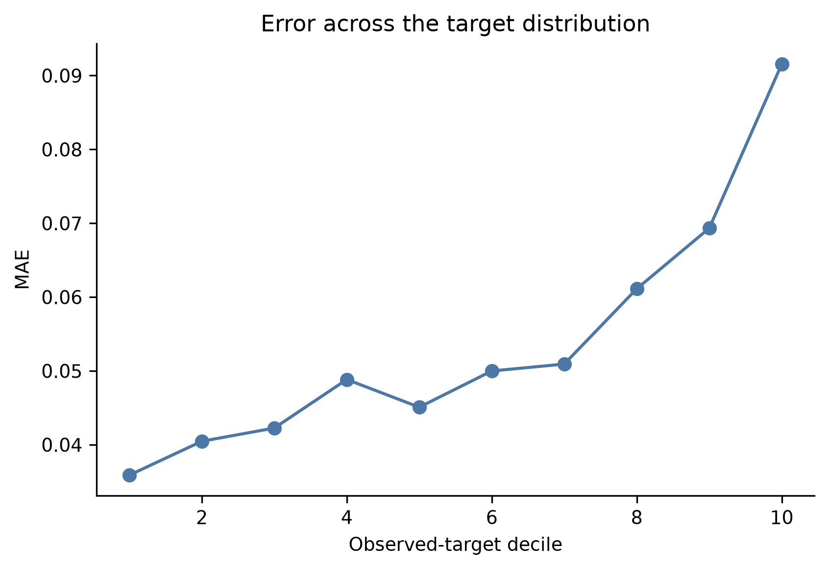
Figure 17. Mean absolute error of the unified model across deciles of the observed target.

3.13 HCP status
No validated HCP observations entered the final database, so no HCP model or HCP metric is reported in this thesis. The 255 provisional CrCoNi HCP configurations remain excluded because their WC values could not be checked against the authors’ reference arrays and because 98 frames had an ambiguous first-shell boundary. This was a deliberate quality-control decision: adding unverified labels would have mixed an unchecked SRO convention into a carefully validated database. HCP SRO prediction therefore remains an open part of the project. The most direct next step is to obtain the authors’ HCP WC reference arrays or code; for a chemically independent HCP set, a complete HfTiZr configuration-plus-SRO dataset would be needed.

3.14 DFT extension results
All four static DFT calculations converged and terminated normally. Table 13 and Figure 18 give the results. Energies are reported per atom and as relative energies within each phase pair, with the lower-energy member set to zero.
Table 13. Static DFT results for the four selected Co-Cr configurations (Co 0.5, Cr 0.5; 2 atoms).
Phase | SRO level | Configuration ID | Target SRO | Energy / atom (eV) | Relative energy (meV/atom)
FCC | Low | gra62121526 | 0.000000 | −3224.251885 | 106.954
FCC | High | gra62121527 | 0.333333 | −3224.358840 | 0.000
BCC | Low | gra64001864 | 0.000000 | −3224.170645 | 0.000
BCC | High | gra62121595 | 1.000000 | −3224.027269 | 143.376

In the selected FCC pair, the higher-SRO configuration was lower in energy by about 106.954 meV/atom. In the selected BCC pair the opposite was found: the low-SRO configuration was lower by about 143.376 meV/atom. The two pairs therefore show opposite trends. This is not surprising, since each pair compares only two specific two-atom arrangements, and the target is an unsigned aggregate that does not distinguish ordering from avoidance.
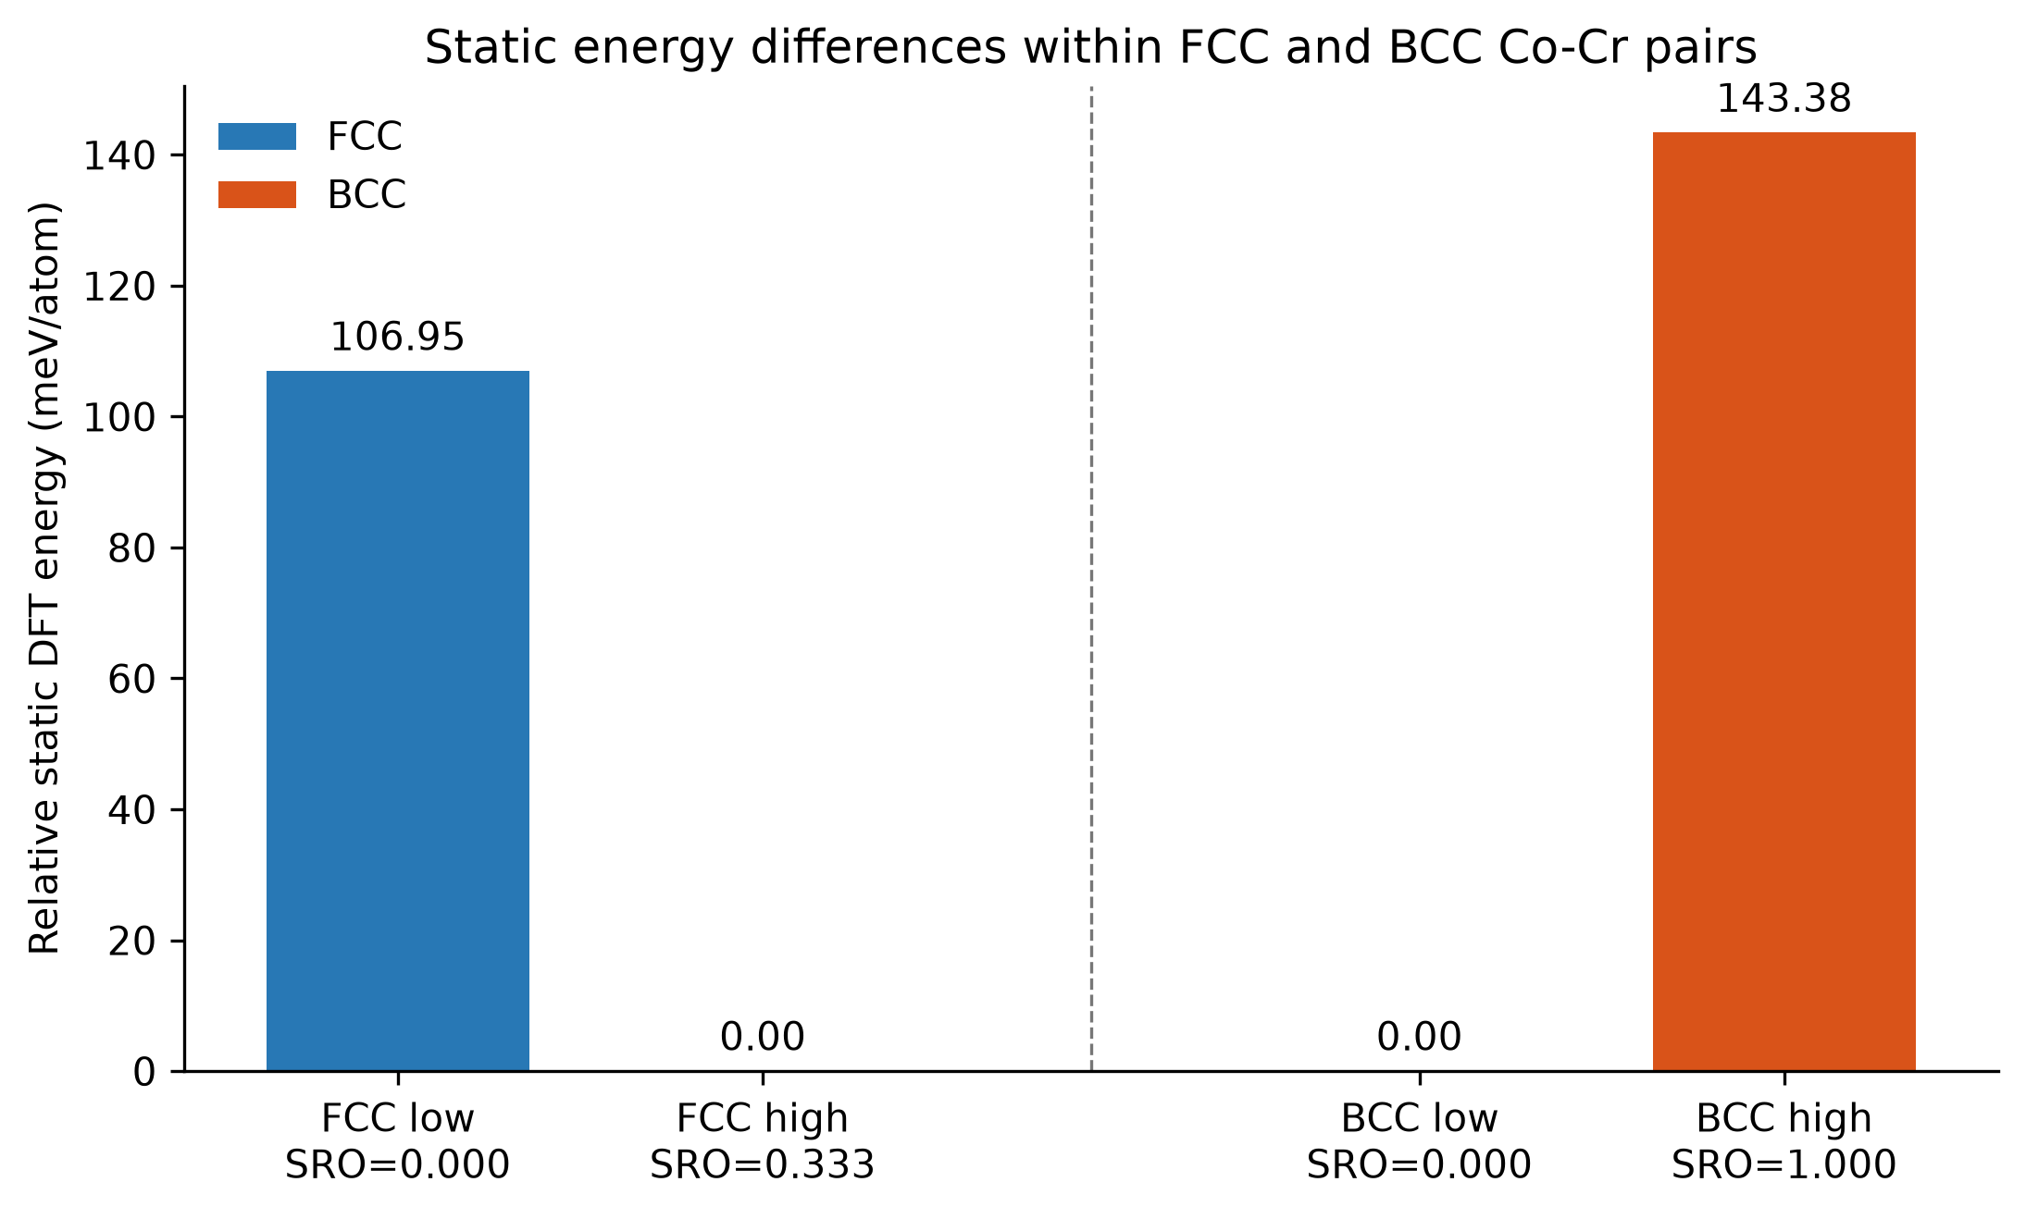
Figure 18. Relative static DFT energies within the selected FCC and BCC Co-Cr pairs.
The selected source configurations with different aggregate SRO labels also exhibit different static first-principles energies. However, because the configurations differ in their detailed initial structural representation (cell shape and symmetry), the observed energy differences cannot be attributed solely to SRO magnitude. The calculations therefore provide only a targeted first-principles comparison and do not establish a universal SRO-energy relationship. The other limitations also remain: only four configurations were calculated, the cells contain only two atoms, no ionic or cell relaxation was performed, no finite-temperature entropy contribution is included, and the target is an unsigned aggregate SRO value. These results complement, but do not change, the conclusions of the main 83,797-configuration ML study.

3.15 Overall progression of the UGP
Table 14 compares the two semesters of the project.
Table 14. Overall progression of the project over two semesters.
Aspect | Semester 1 | Semester 2
Data source | Experimental / literature SRO values | 84k theoretical DFT HEA dataset
Size | 437 rows | 83,797 validated configurations
Phases | FCC 331, BCC 24, HCP 82 | FCC 40,425, BCC 43,372, HCP 0
SRO quantity | Reported pair/shell values from different studies | Mean absolute first-shell WC magnitude; convention reproduced
Features | Composition, shell, temperature, phase + physical descriptors | 348 candidates; 324 / 198 / 10 feature sets
Models | RF, XGBoost, PCA, K-means | Nine regressors; HistGradientBoosting selected
Validation | Single split; 5-fold CV on one cluster | Random, composition- and alloy-system-grouped; five repeated splits
Best result | R² 0.740 (single split); 0.337 mean in CV | R² 0.8997 on unseen alloy systems; 0.8946 ± 0.0187 over five splits
Main limitation | Small, heterogeneous, unbalanced data | One theoretical source; configuration-sensitive predictors; no HCP
Extension | – | Static DFT on four Co-Cr configurations

Over the two semesters the project moved from a small, mixed experimental dataset, in which the results changed strongly with the split, to a large validated theoretical database with grouped validation and stable results. The second-semester study also made clear what the models actually rely on, which is as important as the accuracy itself.
Chapter 4

Conclusions and Future Work

4.1 Main conclusions
- The first-semester experimental dataset of 437 literature-derived SRO observations was useful for exploratory analysis, but it was too small, heterogeneous and unbalanced for stable modelling: a promising single-split FCC cluster result (R² = 0.740) dropped to a mean R² of 0.337 under cross-validation.
- A validated theoretical FCC/BCC SRO database of 83,797 configurations (40,425 FCC and 43,372 BCC) was constructed from the 84k HEA DFT dataset, after reproducing its Warren-Cowley convention and applying strict leakage control.
- Aggregate first-shell SRO magnitude can be predicted strongly within the represented theoretical workflow when the initial pre-relaxation configuration and its derived structural descriptors are available, even when complete alloy systems are held out of training.
- The CV-selected unified model, HistGradientBoosting with 198 BALANCED predictors, achieved R² = 0.8997, MAE = 0.0535 and RMSE = 0.0764 on unseen alloy systems, and a mean R² of 0.8946 ± 0.0187 over five repeated splits.
- Phase-specific models achieved R² of about 0.91 (FCC 0.9058, BCC 0.9154); the gain over the unified model was larger for FCC.
- Initial structural, configuration-sensitive information provides most of the predictive gain.
- Composition alone is insufficient for strong configuration-level prediction in this source (grouped-CV R² = 0.0262, compared with 0.8783 when initial structure is added).
- A compact 10-feature model retained almost all of the performance of the 198-feature model (R² = 0.8917, a loss of only 0.0081).
- The strong dependence on initial symmetry and structure descriptors, which may encode the configuration-generation procedure, creates a transferability caution: the models should be tested on independent data before they are applied outside this source.
- HCP SRO prediction is still unresolved because no validated HCP labels were available.
In addition, a small first-principles extension showed that selected fixed-composition low/high-SRO Co-Cr configurations have measurably different static energies. Because the paired cells also differ in their initial structural representation, these differences cannot be attributed solely to SRO magnitude, and four configurations are insufficient to establish a universal SRO-energy trend.

4.2 Limitations
- The target is an aggregate absolute first-shell value; it removes the sign and the identity of each element pair.
- All validated labels come from one theoretical workflow; transfer to other sources or to experimental data has not been tested.
- The source has no annealing temperature, so temperature-dependent SRO could not be learned.
- Rows share chemistry and generation procedures; grouping by alloy system reduces this dependence but cannot remove it completely.
- The BALANCED set was designed using EDA on the whole dataset, so the study is exploratory rather than a fully prospective test.
- The chemical domain is limited to FCC/BCC configurations of Al, Co, Cr, Cu, Fe, Mn, Ni and Si, and no validated HCP data were available.
- Correlation, permutation importance, group ablation and partial dependence describe associations and do not establish causation.
- The DFT extension used four small two-atom cells with static SCF calculations only, and the paired cells differ in structure as well as in SRO label.

4.3 Future work
- Predict signed, pair-resolved Warren-Cowley parameters instead of only the aggregate magnitude.
- Test the trained models on a second theoretical source and, where the SRO convention allows, on the first-semester experimental data, keeping sources separate when their conventions differ.
- Develop more transferable descriptors and compare models with and without configuration-sensitive structural features.
- Obtain validated HCP WC references for CrCoNi, or a complete HfTiZr dataset, so that HCP alloys can be included.
- Add temperature-dependent data, for example from Monte Carlo simulations, so that equilibrium SRO can be studied.
- Extend the DFT work to larger cells, more compositions and relaxed structures, so that a statistically meaningful SRO-energy comparison can be made.

References
[1] R. Zhang et al., “Short-range order and its impact on the CrCoNi medium-entropy alloy,” Nature, vol. 581, pp. 283–287, 2020.
[2] K. Sheriff, Y. Cao, T. Smidt, and R. Freitas, “Quantifying chemical short-range order in metallic alloys,” Proceedings of the National Academy of Sciences, vol. 121, e2322962121, 2024.
[3] J. M. Cowley, “An approximate theory of order in alloys,” Physical Review, vol. 77, pp. 669–675, 1950.
[4] W. Schweika and H.-G. Haubold, “Neutron-scattering and Monte Carlo study of short-range order and atomic interaction in Ni-Cr,” Physical Review B, vol. 37, pp. 9240–9248, 1988.
[5] R. Bucher et al., “Short-range order in Ni-rich Ni-Ti studied by diffuse neutron scattering,” physica status solidi (a), vol. 175, pp. 527–536, 1999.
[6] J. B. Staunton et al., “A theoretical treatment of atomic short-range order and magnetism in iron-rich b.c.c. alloys,” Journal of Physics: Condensed Matter, vol. 9, pp. 1281–1300, 1997.
[7] K. Li, K. Choudhary, B. DeCost, M. Greenwood, and J. Hattrick-Simpers, “Efficient first principles based modeling via machine learning: from simple representations to high entropy materials,” Journal of Materials Chemistry A, vol. 12, pp. 12412–12422, 2024, doi: 10.1039/D4TA00982G.
[8] K. Li, K. Choudhary, B. DeCost, M. Greenwood, and J. Hattrick-Simpers, “DFT dataset for high entropy materials” (version 2023-04-06), Zenodo, record 10854500, doi: 10.5281/zenodo.10854500.
[9] Y. Rao and W. A. Curtin, “Analytical models of short-range order in FCC and BCC alloys,” Materials Cloud Archive, 2021, doi: 10.24435/materialscloud:qa-ba.
[10] S. Mubassira et al., “Chemical short-range order and its influence on selected properties of non-dilute random alloys,” Computational Materials Science, 2025, doi: 10.1016/j.commatsci.2024.113587.
[11] Y. Cao, K. Sheriff, and R. Freitas, “Capturing short-range order in high-entropy alloys with machine learning potentials,” npj Computational Materials, 2025, doi: 10.1038/s41524-025-01722-2.
[12] Y. Cao, K. Sheriff, and R. Freitas, “CrCoNi_Cao_2022,” ColabFit dataset, 2024, doi: 10.60732/76208b62.
[13] F. Pedregosa et al., “Scikit-learn: Machine learning in Python,” Journal of Machine Learning Research, vol. 12, pp. 2825–2830, 2011.
[14] A. I. Bhatti et al., “High-Entropy-Alloys computational toolkit,” Computational Materials Science, 2024, doi: 10.1016/j.commatsci.2024.113196.
[15] L. Ward et al., “Matminer: An open source toolkit for materials data mining,” Computational Materials Science, vol. 152, pp. 60–69, 2018.
[16] P. Giannozzi et al., “QUANTUM ESPRESSO: a modular and open-source software project for quantum simulations of materials,” Journal of Physics: Condensed Matter, vol. 21, 395502, 2009.
[17] P. Giannozzi et al., “Advanced capabilities for materials modelling with Quantum ESPRESSO,” Journal of Physics: Condensed Matter, vol. 29, 465901, 2017.
[18] J. P. Perdew, K. Burke, and M. Ernzerhof, “Generalized gradient approximation made simple,” Physical Review Letters, vol. 77, pp. 3865–3868, 1996.
[19] G. Prandini, A. Marrazzo, I. E. Castelli, N. Mounet, and N. Marzari, “Precision and efficiency in solid-state pseudopotential calculations,” npj Computational Materials, vol. 4, 72, 2018.
[20] H. J. Monkhorst and J. D. Pack, “Special points for Brillouin-zone integrations,” Physical Review B, vol. 13, pp. 5188–5192, 1976.
[21] N. Marzari, D. Vanderbilt, A. De Vita, and M. C. Payne, “Thermal contraction and disordering of the Al(110) surface,” Physical Review Letters, vol. 82, pp. 3296–3299, 1999.
[22] L. Reinhard, B. Schönfeld, G. Kostorz, and W. Bührer, “Short-range order in α-brass,” Physical Review B, vol. 41, pp. 1727–1734, 1990.
[23] J. M. Cowley, “X-ray measurement of order in single crystals of Cu₃Au,” Journal of Applied Physics, vol. 21, pp. 24–30, 1950.
[24] L. Reinhard, J. L. Robertson, S. C. Moss, G. E. Ice, P. Zschack, and C. J. Sparks, “Anomalous-x-ray-scattering study of local order in bcc Fe_{0.53}Cr_{0.47},” Physical Review B, vol. 45, pp. 2662–2676, 1992.

Appendix A. Representative Records from the First-Semester Experimental SRO Dataset
The first-semester experimental dataset was compiled manually from published literature and contained 437 SRO observations across FCC, BCC and HCP alloys. The complete extraction sheet contains the source information for each observation. A few representative records are shown below to demonstrate the provenance and format of the literature-derived data used in the first-semester study.
Table 15. Representative records from the first-semester experimental SRO dataset.
Alloy system | Phase | Composition (atomic fraction) | Temp. (K) | Shell | SRO value | Source
Cu-Zn | FCC | Cu 0.689, Zn 0.311 | 673 | 1 | −0.1373 | Reinhard et al., 1990 [22]
Ni-Ti | FCC | Ni 0.942, Ti 0.058 | 777 | 1 | −0.0441 | Bucher et al., 1999 [5]
Ni-Cr | FCC | Ni 0.89, Cr 0.11 | 833 | 1 | −0.0874 | Schweika and Haubold, 1988 [4]
Cu-Au | FCC | Cu 0.75, Au 0.25 | 678 | 1 | −0.1520 | Cowley, 1950 [23]
Fe-Cr | BCC | Fe 0.53, Cr 0.47 | 300 | 8 | 0.1596 | Reinhard et al., 1992 [24]

